A dissertation submitted to the University of Greenwich in partial fulfilment of the requirements for the Degree of

Master of Science

in

Computer Forensics and Cyber Security

AI-Driven SIEM Workflow Automation and Zero-Trust Endpoint Protection for Securing Cloud Supply Chains

Name: Muhammed Afnaan
Student ID: 001466352

Supervisor:Nagmeh, Moradpoor
Submission Date: September 2026
Word count: 19,723

AI-Driven SIEM Workflow Automation and Zero-Trust Endpoint Protection for Securing Cloud Supply Chains

Computing & Mathematical Sciences, University of Greenwich, 30 Park Row, Greenwich, UK.
(Submitted 1 September 2026)

Abstract

Cloud computing has significantly transformed modern security operations center (SOC) environments by actively adopting them. Cloud environments have significantly transformed these centers by introducing highly distributed infrastructures that generate an increased volume of security telemetry from existing cloud endpoints, authentication systems, and cloud services. The only limitation that it has is that it requires manual creation of rules and predefined thresholds, which causes a struggle to adapt to emerging attack techniques.
The dependence on predefined rules and manual investigation poses substantial operational issues, including alert fatigue, analyst burnout, and delayed incident response. Corresponding to these challenges, the proposed model investigates the application of artificial intelligence to security workflow automation. As a layer one, zero trust architecture is another independent component that incorporates a complementary security layer, addressing the enforcement side of security through continuous verification, application control, default deny policies, and establishing least privilege principles.
This reliance poses substantial operational issues, including alert fatigue and increased effort for analysts, which results in delayed incident response. Furthermore, this study investigates the use of artificial intelligence in security-based automation. Zero trust architecture is another independent component that, when coupled, the combination of these two approaches addresses a research gap by illustrating how AI-driven workflow automation may be successfully linked with zero trust principles and enforcement rules to construct a more flexible security operational model.
The perspective of this research is to design, implement, and evaluate an AI-driven SOC workflow automation architecture that transforms security alerts into structured actionable insights, improving incident response while incorporating zero trust controls as an additional layer of defense to strengthen the cloud endpoint. The proposed architecture integrates technologies such as Amazon Web Services for cloud workstations, Elastic SIEM as a central endpoint monitoring platform, Tines AI as the AI-driven workflow automation tool, and a zero-trust endpoint software solution for policy enforcement.
This study shows how AI can make SOC workflows intelligent and automated, while zero trust can make the cloud endpoint more controlled and resilient by implementing a cloud-based SOC environment consisting of AWS Windows Server 2025 as a cloud endpoint connected to Elastic Defend, which collects endpoint telemetry and poses customized detection rules based on Windows event ID 4672, identifying privileged account activity. When the detection rule was triggered, the alert was automatically transmitted to Tines AI through webhook integration, whereby AI processes the security alert and generates a structured incident summary, providing recommendation steps for analysts. In parallel to this, it embeds zero-trust architecture through its controls, such as application allowlisting, default-deny enforcement, and policy-based access restrictions, to control the behaviour of the endpoint.
The proposed model was evaluated by simulating a privileged access activity in the cloud endpoint to demonstrate the end-to-end workflow from endpoint event generation to SIEM detection, AI-driven analysis, and analyst notification. The evaluation of the proposed architecture demonstrates that the integrated architecture could automate several manual stages of alert handling carried out by analysts and transform those low-level inputs into structured investigation intelligence, eliminating the need for analysts to manually interpret every raw alert and potentially use AI-driven workflow automation supporting their SOC operations. The zero trust layer complements this workflow by providing an endpoint enforcement layer in the same cloud endpoint.

Acknowledgement

I would especially like to thank Nagmeh Moradpoor for agreeing to be my supervisor and for his consistent advice, feedback, guidance and support throughout the lifecycle of this Msc Cybersecurity and Computer Forensics
I want to thank both Nagmeh Moradpoor and Ehsan Nowroozi for agreeing to have the project demonstration on the schedule day.

\

Table of Contents

Contents
Chapter 1 Introduction: 7
1.1 Overview 7
1.2 Background and Context: 7
1.3 Problem Statement 13
1.4 Research Aim 14
1.5 Research Objectives 14
Chapter 2 Literature review 15
2.1 Introduction 15
2.2 Background Research (Secondary Research) 17
2.2.1 Incident response and SOC automation 17
2.2.2 Zero Trust Architecture 19
2.2.3 AI Workflow Automation 21
2.2.4 SIEM Optimisation Techniques 24
Chapter 3 Requirements Analysis 26
3.1 Overview 26
3.2 Functional Requirements 26
3.3 Hardware and Software Requirements 28
Chapter 4 Methodology 31
4.1 Overview 31
4.2Research Philosophy 32
4.3) Evaluation of the chosen Methodology 32
4.3 ii) Justification on the methodology 32
4.3 iii) Strengths of the design science research 32
4.3 iv) Practical validation 34
4.3 v) Limitation of the design of scientific research 34
4.3 vi) Conclusion 35
5) Social, Ethical and Legal Issues 35
Chapter 6 Designing the solution 36
6.1 Overview 36
6.3 Purpose of the proposed model 37
6.4 Overview of the proposed model 37
6.5 Demonstration of the design 49
6.6 Layered Design 56
Chapter 7 Implementation 59
7.1 overview Step by step setup of the project 59
7.2 Deploying the AWS Endpoint 60
7.3 Installing Elastic Agent 60
7.4 Deploying Elastic Defend 61
7.5 Creating Detection rule 61
7.6 Integrating Elastic SIEM with Tines 62
7.7 Threatlocker demonstration 63
7.8 Implementing application control 63
7.9 Ringfencing Through Threatlocker 65
7.10 Storage Control 65
Chapter 8 Implementation testing and Demonstration Overview 66
8.1 Overview 66
8.2 Practical demonstration 66
8.3 Screenshots 66
8.2 Practical demonstration II 98
Chapter 9 Evaluation of the design 106
Chapter 10 Critical Evaluation 108
10.1 Findings Against Research 108
10.2 Metric Evaluation 109
10.3 Evaluation Against Threat landscape 111
11) References 113
12 Appendices 115

Chapter 1 Introduction:

1.1 Overview
Modern Security Operations Centres (SOCs) heavily rely on cloud-enabled infrastructures and dispersed endpoints, resulting in a complexity of security events that tests the capabilities of conventional SOC operations. As security operations teams are required to identify, analyse, and respond to threats rapidly, systems for the detection and mitigation of cyber attacks are essential. Although SIEM platforms are proficient in monitoring network and endpoint activities, alerts can be excessive at times, unprioritized, and may lack executive-level clarity, resulting in delayed responses and fragmented decision-making. This project investigates how integrated Zero-Trust endpoint controls combined with automated workflows can enhance operational security, streamline incident response and improve communication between technical teams and management, distinguishing a real-time SOC workflow with manual configuration

The research will critically survey academic literature, vendor documentation, and industry frameworks such as NIST, CIS Controls, ISO/IEC 27001 and GDPR to evaluate how risk-based controls should be designed for modern SOC environments. It will analyse application allowlisting and device control through the Threatlocker as a zero-trust enforcement mechanism, while Elastic SIEM will provide structured event correlation and monitoring. Automation using Tines will be employed to transform raw security events into actionable alerts and executive summaries to establish a possible automated workflow in incident investigation and operational response.

1.2 Background and Context:
Evolution of cloud infrastructure and cloud security

Cloud environments nowadays have changed dramatically from being optional infrastructure solutions to being a fundamental component of digital strategy. Digital infrastructure organisations typically deploy, monitor, and secure digital infrastructure quickly and efficiently. The expansion of cloud computing has eventually resulted in businesses with a potential advantage in terms of scalability, flexibility and accessibility throughout the global landscape. As a result of this change, platforms such as Amazon Web Services and Microsoft Azure have become indispensable pillars. Although these platforms serve as the basis for modern digital transformation for various industries and public services, healthcare, finance and technology, they make rapid innovation and distributed mobility possible. Support for enterprise adoption levels and strategic reliance on cloud infrastructure has significantly contributed to this rapid change.

The evolution of cloud infrastructure is examined in a thematic approach covering the cloud threat landscape, security considerations across cloud platforms, challenges faced by SOC evolution, AI-driven workflow automation, and zero-trust frameworks for the enforcement of security.

- Emerging cloud threat landscape

The transition to cloud computing has introduced significant complexity into enterprise environments and has also resulted in a significant shift in the widespread adoption of hybrid cloud models, despite this rapid expansion. Currently, approximately 85% of organisations are operating in hybrid environments. a hybrid environment. This trend indicates the fact that the adoption of the cloud is a multi-dimensional integration of several infrastructures and not a replacement of traditional systems. There are opportunities for optimisation and flexibility, but also challenges in relation to system governance, distribution of tasks and interoperability.

The nature of cyber risk has shifted from perimeter intrusion to persistent exposure. This shift marks the emergence of persistent exposure across interconnected trust boundaries. Each application programming interface (API) call, authentication request, and system record adds to of telemetry from endpoints, authentication systems, and distributed services.

- Security considerations in cloud platforms

Platforms such as Amazon Web Services (AWS) serve as a central point in the ecosystem of cloud computing, valued for their scalability, flexibility, and utmost support for highly distributed, data-driven workloads in modern organisations to build, deploy and operate their infrastructure. AWS is known as a custodian of vast digital ecosystems, where critical assets such as data, identity, applications, and computational resource coverage interact on a large scale across global environments. Within this expansive architecture with a promise of resilience and efficiency, there exists a recurring pattern of security challenges that consistently contribute to cloud security incidents. As modern organisations rely on AWS to host sensitive business operations, customer data, and critical services, the threat landscape expands in parallel with the very same scale and complexity, introducing multiple security threats and vulnerabilities.

Firstly, Services such as S3 buckets, IAM roles, security groups, and database snapshots, are frequently misconfigured, exposing sensitive data arising from the very core operational complexity of managing distributed cloud environments.

Secondly, insecure API misconfiguration also tends to represent a significant attack surface within AWS, as we know that all services ranging from compute to storage and identity are accessed and managed through APIs, yet these interfaces could potentially become exploitable entry points, leveraging attackers' access to extract sensitive data and alter system configurations due to lack of proper authentication.

Thirdly, identity and access management (IAM) weaknesses arising from AWS environments tend to form a centre of vulnerability to cloud security in terms of access control, weak authentication mechanisms and failure to enforce least privilege significantly exposing risk. Once credentials are compromised through phishing, token theft or session hijacking, attackers can directly authenticate into AWS systems through lateral movement across interconnected services.

- SOC challenges and alert fatigue in the cloud

Traditional security operations centre (SOC) models are used by companies to manage the growing risks associated with cloud-based infrastructures, remote work, and IoT ecosystems, all of which are linked to one another. These models play a vital role in identifying and detecting malicious activity or behaviour across endpoints, networks, applications, and cloud infrastructure, as well as in the security telemetry generated from these sources.
However, as modern organisations increasingly adopt cloud computing, the volume, capacity, and velocity of security events have significantly increased, creating sophisticated and evolving cyber threats at an accelerated rate.

The signature-based detection model is widely used in modern organisations to identify security threats which are malicious in nature by comparing system activity against a database of predefined set of malicious indicators such as malware signatures, file hashes, and specific network patterns, similar to a digital fingerprint mechanism. For example, an endpoint protection system might generate an alert when a file corresponds with a known ransomware attack or when network traffic contains a recognised malicious payload pattern with a known vulnerability inside it. Although signature-based detection remains effective against previously identified threats, the only limitation it has is the ability to detect unknown threats. Considering the modern world where AI is actively being used, attackers are now using advanced adversarial tactics to deploy new model radiancy and exploit zero-day vulnerabilities. Threats that do not match existing signatures can eventually bypass traditional detection mechanisms entirely.

The signature-based detection model is widely used in modern organisations to identify security threats that are malicious in nature by comparing system activity against a database of a predefined set of malicious indicators, such as malware signatures, file hashes, and specific network patterns, similar to a digital fingerprint mechanism. For example, an endpoint protection system might generate an alert when a file corresponds with a known ransomware attack or when network traffic contains a recognised malicious payload pattern with a known vulnerability inside it. Although signature-based detection remains effective against previously identified threats, the only limitation it has is the ability to detect unknown threats. Considering the modern world where AI is actively being used, attackers are now using advanced adversarial tactics to deploy new model radiance and exploit zero-day vulnerabilities. Threats that do not match existing signatures can eventually bypass traditional detection mechanisms entirely.

Despite these limitations, traditional SOC technologies continue to be vital components of modern cybersecurity operations. This is because they provide useful tools for event collection, correlation, and security visibility across complex infrastructures. Threats continue to become more sophisticated through automation and artificial intelligence, which imposes challenges to traditional SOC models in the increased inefficiency of operating intelligently and adaptively to analyse large-scale telemetry in prioritising security events and reducing false positives. This trend has driven the emergence of AI-driven SOC workflows via artificial intelligence and automation technologies that enhance traditional SIEM capabilities by transforming alerts and responding intelligently.

In reality there are some limitations in SIEM platforms which give rise to several operational challenges, such as

Alert Overload:
A situation where security analysts and IT teams get overwhelmed by the volume of alerts in a state arising from overextensive detection rules in SIEM platforms Many of these alerts are low-priority or false positives, which result in delayed responses, missed attack patterns, and exhaustion for the analysts and IT teams.

Manual Triage:
Manual triage refers to a process of reviewing, validating, and prioritising alerts to determine if they indicate a legitimate threat or a false positive, specifically carried out by security analysts. Any delay in escalating a possible threat may increase the exposure time for attackers, risking the oversight of legitimate attacks and potentially leading to a data breach.

Alert Fatigue
Continuous exposure to repetitive alerts from SIEM platforms, most of which are false, leads to psychological desensitisation in analysts.

Analyst Burnout
In the context of security information and event management (SIEM) systems, the term "analyst burnout" refers to a condition in which analysts have a severe lack of motivation to monitor, investigate, and respond to alerts and telemetry logs.

AI Workflow Automation

The rise of cloud infrastructure across distributed and highly connected environments has imposed limitations on traditional SIEM and SOC operations. AI workflow automation is considered dominant in the industry, reducing these limitations through its significant advancement in cloud security detection capabilities at endpoints and overall reducing the manual workload in the SOC.

AI is now actively being integrated with SIEM environments to represent a transition from reactive security operations to adaptive intelligence security orchestration in the SOC workflow. AI combines machine learning and deep learning methodologies to fortify security operations across various phases of the detection and response process. AI automation enables systems to examine substantial volumes of network traffic, authentication operations, system logs and behavioural patterns in real time.

The ability to detect complex assaults, such as advanced persistent threats and zero-day attacks, within SIEM systems is improved through the deployment of machine learning languages in SOC workflows as a result of the analysis of massive volumes of security logs and telemetry. This method is one of the ways that AI automation achieves its objective of improving threat detection.

Natural language processing technologies are also being used to help computers understand, interpret, and create human languages. One way this is achieved is by transforming unorganised texts into organised information that has practical value, allowing analysts to potentially generate contextual and human-readable security insights with the assistance of NLP.

- Zero Trust Framework

Zero-trust architecture is a theoretical philosophy that is based on the principle of "never trust, always deny." Regardless of whether the access request originates from within or outside the organization's network, this indicates that no user, device, endpoint, application, or system is automatically trusted. This is the case regardless of the origin of the request. With the current state of affairs, zero-day assaults bring to light the fact that organisations, rather than their employees, might be oblivious of vulnerabilities that exist inside their systems. It is possible to exploit vulnerabilities of this kind just by virtue of the fact that an application has been granted access to particular files, which indicates that it possesses authority. Because of this, the need of zero-trust architecture in contemporary cloud ecosystems is becoming increasingly apparent. Before allowing access to the organization's resources, each and every access request that comes from a user or application must first be subjected to continuous verification, contextual validation, and dynamic risk evaluation.
This approach shifts cybersecurity from a static perimeter defense to a model that emphasizes identity-centric and behavior-aware security enforcement. It is evident that this architecture is becoming the standard in the industry.
One of the most important security principles that develops from zero-trust architecture in modern cloud systems is referred to as "default deny." This is a phrase that means "deny all, permit by exception," and its purpose is to ensure that all traffic, access requests, and communications are banned unless they are specifically authorised in accordance with the NIST 800 security policies that have been set.

1.3 Problem Statement
Modern cloud infrastructures tend to generate vast volumes of security telemetry from endpoints, cloud services, and authentication systems. Security information and even management platforms, such as Elastic SIEM and Splunk, used in security operations centers, establish support for trade detection; however, despite providing visibility into security events, these platforms remain largely dependent on predefined detection roles and human analysts to investigate, validate, and respond to the alerts.
As cloud infrastructures continue to expand in terms of scalability and complexity, associated analysts face an increasing volume of alerts caused by repeated rules, low priority, or false positives. This situation eventually creates an operational challenge for SOC analysts.

Monitoring endpoint elementary alerts can be time-consuming and overwhelming under search conditions; misconfigurations may remain undetected. Consequently, security effectiveness becomes a high priority to human capacity rather than continuous and automated enforcement.
Traditional SIEM platforms are effective in generating alerts based on the detection rules, but they lack the intelligence to automate and validate, which frustrates security posture.

A small misconfiguration can compound the speed of modern cyber attacks as threat actors rapidly exploit exposed services, perform reconnaissance, escalate privileges, and move laterally across cloud environments. Any delay in detection or response to the alerts could potentially increase the opportunity for attackers to compromise sensitive systems and data. A significant example could be the Cam4 data breach, which exposed 11 billion records due to a misconfiguration in the production Elasticsearch, i.e., the server of the Elastic SIEM. The administrator deployed a production logging cluster containing 7 terabytes of user logs with no protection or encryption, bypassing Elasticsearch's built-in access controls and the internal network of Cam4 to the public internet.
This problem is further extended by the compound of the speed of modern cyber attacks, as threat actors rapidly exploit exposed services, perform reconnaissance, escalate privileges, and move laterally across cloud environments with minimal access to systems. Any delay in detection escalation or response potentially increases the possibility of a cyber attack.

Therefore, there is a need for a more adaptive security operation model, mainly an AI workflow automation model that reduces reliance on manual investigation while also validating cloud security configurations by enforcing protective control using advanced features. This research examines whether integrating AI-driven workflow automation with zero-trust architecture in cloud endpoints improves the efficiency of SOC workflows or prevents cyberattacks.

1.4 Research Aim
The aim of this project is to design, implement, and evaluate an AI-driven workflow automation system integrated with zero trust and point security control to secure cloud infrastructure against modern cyber threats.
This project will develop an advanced SOC operational model that demonstrates a hybrid defence architecture aimed at improving operational resilience and reducing dependency on manual security operations by leveraging AI-assisted orchestration and implementing zero-trust security principles at the cloud endpoint level.

1.5 Research Objectives
Objective 1: To design and implement AI-driven SOC workflow
To design and implement an AI driven SOC workflow model by using technologies such as AWS ,Elastic SIEM and Tines AI

Objective 2: Implementation of rule-based detection for privileges Account activity through Event ID 4672
This objective aims to implement detection rules under event ID 4672 signifying privilege activity in the Elastic SIEM.
Objective 3: Implementation of Zero Trust Endpoint Security Architecture
This objective focuses on implementing a zero-trust architecture using ThreatLocker, a software solution that enforces the zero-trust principle, featuring application allowlisting, default deny policies, and behavioural restrictions on cloud endpoints.

Objective 4: Evaluation of Zero Trust Policy Enforcement and Endpoint Behavioural Control
The aim of this objective is to explore how the implementation of policies on the cloud endpoints prevent unauthorised execution and minimise risks from zero-day vulnerabilities via the use of the Threatlocker feature that consists of application control, storage control and ring-fencing.
Objective 5: Implementation of Rule-Based Threat Detection Using Event ID 4672
This objective emphasizes on establishing a rule-based detection approach that will use event code 4672 to detect login attempts to the cloud endpoint and then produce security warnings based on their severity.
Objective 6: AI-driven SOC alert transformation and analyst workflow optimization
This aim focuses on the establishment of an AI-driven security workflow automation that will convert raw SIEM alerts into structured, human-readable incident intelligence and automatically deliver them to security analysts through email notifications. This would reduce the requirement for security analysts to manually handle warnings.

Chapter 2 Literature review

2.1 Introduction
This literature review examines existing research on Zero Trust Architecture (ZTA), AI-driven Security Operations Center (SOC) automation, smart SIEM systems, and risks from cloud security misconfigurations, all under the umbrella of 'AI-Driven SIEM Workflow Automation and Zero-Trust Endpoint Protection for Securing Cloud Supply Chains'. The goal of this review is to examine previous approaches, identify methodological limitations, and attempt to identify research gaps to support the proposed dissertation.
This research investigates the effectiveness of multiple layers of security within the cloud supply chain. This research explores ways to enhance multiple layers of cloud supply chain security through intelligent automation and stringent access control mechanisms. This research explores ways to enhance multiple layers of cloud supply chain security by implementing intelligent automation and strict access control mechanisms. Cloud supply chain security is a network of interconnected security layers where each protects a different part of the cloud ecosystem. As cloud environments rely on many independent systems that identify platforms, monitor tools, deploy pipelines and endpoint agents, each induces its own risk. This challenge may oversimplify its complexity. In practice, securing cloud environments thus requires interaction of several independent components, including threat detection mechanisms such as SIEM platforms, zero-trust access control models and vulnerability assessment.
To account for this complexity, the literature review adopts a thematic decomposition approach, examining the problem across five key domains mainly incident response and SOC automation, zero-trust architecture, AI workflow automation, SIEM optimisation techniques, and cloud weaknesses. This structural approach reflects a layered structure of cloud supply chain security, where each security component contributes to improving the overall cyber resilience of clouds and environments.

This literature review is a collection of academic research databases that include IEEE Xplore, SpringerLink and ScienceDirect, alongside established cybersecurity frameworks and industry resources such as NIST, OWASP, MITRE ATT&CK, CVE databases, AWS security documentation and vendor documentation. Peer-reviewed research articles and supporting industry documentation were examined to analyse existing methodologies and evaluate systems, thereby providing a practical cybersecurity context for understanding current security implementations.
Survey papers were excluded to maintain a focus on specific implementations and evaluated systems. This dissertation addresses the research gap by analysing the limitations identified in current approaches. Following the review of existing literature, the dissertation presents primary research conducted through practical implementation and evaluation of the proposed security architecture.

Literature review is organised into four thematic groups
Incident response and SOC automation
Zero Trust Architecture Implementation
AI Workflow Automation
SIEM Optimisation Techniques

2.2 Background Research (Secondary Research)

2.2.1 Incident response and SOC automation
When modern networks generate massive amounts of data, it becomes challenging for security teams to identify threats within them. SOC plays a crucial role by proactively monitoring and alerting through the collection and analysis of threat data. These systems create significant operational challenges for various sources, including firewall logs, network logs, server logs, intrusion detection systems, and intrusion prevention systems like SIEM systems and threat intelligence platforms. These systems create significant operational challenges for various security sources, and the exact tools can change depending on the organisation's network requirements. This setup may include risk and compliance systems, governance protocols and vulnerability assessment. However, as organisations increasingly adopt cloud-based infrastructures like AWS EC2 instances, SOC teams face significant operational challenges due to the high volume of authentication events, basic endpoint log data, and suspicious login activities generated by these systems. SOC depends heavily on security analysts manually interpreting SIEM-generated alerts, which results in increased alert fatigue, delayed investigation and a higher possibility of missing security incidents.
The increasing complexity of cloud environments has therefore caused a significant demand for more adaptive and intelligent approaches to incident detection and response.

Existing research has explored the integration of artificial intelligence and machine learning techniques into SOC operations to improve incident response

Researches proposed an AI-powered framework for detecting cyber incidents that applied machine learning techniques to security workflows. Their approach utilised random forest algorithms Isolation Forest mechanisms and a hybrid random forest LSTM.

Random Forest →machine learning algorithm that Identifies malicious activity.
Isolation Forest →for anomaly detection
LSTM→Long-Short Term memory for understanding sequence of patterns
This research demonstrated that AI-driven detection models can improve threat detection by analysing behavioural patterns rather than solely relying on predefined signatures.
However, they rely heavily on benchmark datasets, which may not accurately represent complex real-world enterprises.(Farzaan et al.2026)

This emphasises the necessity of an AI-driven SIEM workflow automation approach to reduce alert fatigue, improve incident response efficiency, and strengthen cloud endpoint protection.

Similarly, researchers explored the concept of integrating artificial intelligence in SOC workflows to improve their automation and limit traditional SOC workflows, which require analysts to manually investigate a large volume of SIEM-generated alerts.

The proposed approach aimed to develop an AI-based automated incident response framework built to reduce the manual response time required for SIEM-generated investigations in reviewing alerts and enhancing the overall efficiency of security operations.

This research carried out a quantitative experimental methodology by comparing performance metrics before and after implementation in SOC workflows. This approach collected security telemetry from sources such as firewalls, intrusion detection and prevention systems (IDS/IPS), and SIEM platforms. The researchers simulated controlled attack scenarios, including phishing, malware, DDoS, and ransomware, within a laboratory environment to evaluate the effectiveness of AI-driven incident response capabilities.

When the results came out, it was seen that AI-based automation significantly improved SOC efficiency, controlling incidents, action time, phishing, malware, and DDoS (120 seconds), and increased average response time from 45 minutes to 10 minutes. Furthermore, AI-driven implementation also reduced false positives from 500 to 150 alerts per month and improved detection performance compared to the traditional rule-based approach. Narayan et al. (2025)

However, despite these improvements, limitations were still present, as the research primarily focused on measuring improvements in detection and response performance rather than implementing a complete operational workflow that involves automated alert enrichment, threat prioritization, investigation, and response orchestration for a complex cloud-based enterprise environment where security events are continuously generated across distributed endpoints and services as of today. The results indicate the necessity of an AI-driven SIEM workflow automation approach to connect threat detection models with real-world security operations. This will improve incident handling in cloud environments by using automation, continuous monitoring, and smart analysis.
Narayan, Yogendra, et al. . 18 Sept. 2025

2.2.2 Zero Trust Architecture

This section explains papers used under the Zero Trust Architecture concept
Adoption of cloud computing and hybrid IT infrastructures has significantly transformed the modern cybersecurity threat landscape. Considering the threat landscape, attackers are presented with a variety of opportunities to exploit weaknesses associated with cloud platforms such as AWS, Azure and Google Cloud. As these cloud platforms carry out a castle-and-moat security analogy throughout their working, organisations establish a strong external defence perimeter with the use of firewalls, VPNs and network segmentation to protect internal resources. The ideology of this model is that anything located inside the network boundary is trustworthy, while external entities are considered untrusted; however, this approach becomes ineffective in modern dynamic cloud environments as organisations migrate critical workloads, applications and sensitive information across dynamic cloud platforms and access them by users from different geographical locations, devices and networks.
This shift creates several cloud-specific security challenges, such as
Network perimeter:
The absence of a fixed network perimeter may increase the risk of unauthorised access through open internet connections. This is because cloud applications mainly reside on public-facing internet infrastructure, so they are constantly vulnerable to attackers. to attackers at all times. actively exposed to attackers every time. Example: If an attacker compromises a user or application, they may eventually gain access to sensitive information like legitimate credentials.
Risk of lateral movement:
The standard cloud configurations inherit a large amount of implicit trust within the firewalls and VPNs, as firewalls and VPNs route traffic based on IP addresses and network ports. They are not aware of users and devices. Once a user's login has been validated, this configuration grants them quick access and predetermined rights based on their credentials. It is possible for attackers to inherit the same rights that are allocated to legal users. This can result in privilege escalation, which gives attackers the ability to travel between cloud workloads, access sensitive information, and compromise more resources.
Risk of identity access management: Access management frameworks improve user permissions by assigning them through authentication and authorisation processes; however, compromised credentials can create significant security risks, as when an attacker successfully obtains an identity with elevated permissions, they may gain access to sensitive resources, modify configurations, and exploit connected services. SAAS challenges: There has been a rise in the risk of misconfigurations, which has made it difficult to manage fragmented security rules across distributed systems. These systems include various cloud providers, software-as-a-service platforms such as Amazon Web Services and Microsoft Azure, and serverless environments. Phishing tactics that are AI-assisted are currently being aggressively deployed by attackers. For the purpose of exploiting these vulnerabilities and gaining access to legitimate credentials, attackers are employing techniques such as credential theft, session hijacking, and ransomware assaults.
For example, when an attacker deploys an AI-assisted phishing technique to compromise an employee's identity or password Traditional perimeter-based models may fail here because attackers are no longer attempting to break through the network boundary; instead, they are rooting their way through authorised identities by stealing credentials.
Therefore, the disappearance of the traditional network perimeter and increased reliance on cloud-based identities have increased the necessity for zero-trust architecture. As zero trust architecture revolves around the principle of never trust, always verify, where every user device, application and access request must be continuously authenticated, authorised and monitored before any further steps to reduce the impact of compromised identities and enforce least privilege access and adaptive security decisions based on contextual information.
Recent research has also highlighted the enhancement of zero trust frameworks by integrating machine learning-based trust management systems within cloud endpoints. This integration demonstrates that trust is no longer treated as a binary decision but rather as a dynamic probabilistic evaluation. In this approach, machine learning models support the policy decision layer by enabling a contextual assessment of user behaviour, device states, and environmental signals. This improves continuous monitoring in systems, generating adaptive trust scores and allowing them to operate with greater flexibility in environments where risk conditions are constantly changing. However, delayed logs, misconfigured sensors, or incomplete telemetry can also affect the outcomes of trust evaluations. Zero-trust architecture is implemented through a dynamic policy enforcement mechanism that regulates policies for application users and files, as mentioned by Narasapa. This risk score should be determined based on the threat's conduct and associated context, and risk-adaptive access control methods should be used. In addition, any anomalous behaviour discovered within the application ought to be explored by means of anomaly detection models, such as the isolated forest technique. It is possible to achieve a solid security posture within cloud endpoints through the integration of risk-adaptive access control and anomaly detection, which in turn makes it easier to orchestrate automated responses. 2025, according to Narasappa.
However, from this perspective, Zero Trust Architecture exhibits theoretical resilience but lacks practical enforcement. The principle of 'never trust, always verify', i.e., the core of zero-trust architecture, fundamentally depends on assuming verification mechanisms are constant without any interruption in endpoints, as endpoint-centric mechanisms are essential for translating zero-trust principles into operational reality for organisations.This creates a gap between theoretical zero trust models and their operational implementation.
ThreatLocker is one such tool, which provides a practical enforcement layer for zero trust architectures by implementing a default deny model. It carries out the default deny model by blocking all application executions by default unless they are authorised through predefined policies. This platform addresses these issues by implementing an elevation control mechanism for temporary policy-based privilege escalations without granting permanent administrative rights to users during their learning phase. During this phase, the system observes application behaviour and builds application definitions based on observed execution patterns, file hashes, and dependencies.
(ThreatLocker, Inc.” www.threatlocker.com)

2.2.3 AI Workflow Automation

This section includes IEEE research papers that align with the theme of AI-driven workflow automation within Security Operations Centers (SOCs).
The primary goal of this theme is to integrate artificial intelligence into security operations workflows, allowing for automated, context-aware, and scalable incident handling. The volume and velocity of alerts generated by SIEM systems may exceed the capacity of human analysts, resulting in delays, alert fatigue, and inconsistent response actions. AI workflow automation addresses the challenge by transforming raw alerts into structured insights, summarised viewports, and briefings, as well as initiating predefined response actions that do not require human intervention. Instead of treating detection as the ultimate goal, why not investigate alerts and turn them into intelligent decision support and automated execution to highlight AI's role in summarising complex event data in the modern world.

The rapid expansion of artificial intelligence has fundamentally transformed the cybersecurity threat landscape. The overview of cybersecurity has shifted from human versus AI to an AI versus AI scenario, as modern attacks increasingly utilize AI-powered techniques to automate reconnaissance, generate sophisticated phishing campaigns that target sensitive credentials, manipulate machine learning models, understand user behavior, and develop adaptive malware capable of evolving in response to defensive mechanisms. Cyber threats are no longer static, but as they continuously adapt to dynamic changes with the evolution of AI, organizations further require equally intelligent defensive capabilities capable of operating at machine speed.
Adversarial AI has become one of the most significant issues recently, as attackers intentionally manipulate machine learning systems by injecting malicious input, poisoning the training data to influence the model predictions and expose sensitive information. Through the help of these techniques, attackers can persist within cloud environments for a long time while also continuously learning the behavior of their surroundings, which will allow them to change their attack strategies and evade detection by imitating legitimate user activities.
As a result, organizations tend to move further toward adopting AI into their defensive architecture to defend against these threats. enhances incident response by analyzing large volumes of security telemetry data intelligently and quickly to identify deviations from normal user device and network behaviour. On this note, it also improves the quality of security alerts by enriching them with contextual information derived from multiple security sources. It connects information from endpoints, basic login records, network activities, cloud actions, and threat data, giving analysts a complete view of security incidents. These capabilities, the mean time to detect and the mean time to respond, help analysts overcome the stress of manual work.

Existing research on adopting AI workflow automation in SIEM platforms has increasingly improved threat detection and provided an intelligent response system. Regarding this, (Chyun Horng Chi) carried out research on integrating AI into SIEM systems to develop a SIEM security email alert system capable of automatically converting raw SIEM log data into structured and customised security reports. The authors demonstrated the practical implementation of the system in sequential stages by inserting SIEM-generated log files into it and extracting the relevant security events. This system automatically filters extracted log data and inserts only relevant information with predefined email templates, transforming raw security events into structured investigation summaries suitable for communication with clients. This reduced the need for manual reporting tasks, minimised human errors, and improved consistency in incident communication; however, several limitations persist. First, the system operates only after SIEM alerts have been generated, which does not contribute to trade detection or incident prioritisation. The framework primarily automates email generation rather than the incident response life cycle. Cybersecurity is all about the incident response lifecycle. Although this research improves SOC operational efficiency, it is restricted to post-detection communication workflows rather than end-to-end SOC automation handling the entire life cycle of a security incident.
security incident.

Although Chyon Hong Chi researched such systems that support procedural automation, there is a limitation regarding intelligence in alert prioritisation. An absence of intelligence in alert handling can lead to large-scale consequences.

A notable example can be seen in the CAM 4 data breach, which approximately exposed 10.88 billion records publicly accessible to everyone due to a new misconfiguration in the Elasticsearch database lacking authentication controls. In this attack scenario, the attackers used basic HTTP queries to access sensitive data, to bypass systems. The misconfiguration ultimately allowed large-scale data retrieval without even the need for privilege escalation, highlighting a critical attack in cloud environments where sensitive information, including names, email addresses, IP logs and payment-related data, is widely accessible online, allowing attackers to deploy secondary attacks using their credentials to exploit them individually through phishing emails, identity theft and ultimately social engineering.
This case is for a scene of huge devastation caused by a misconfiguration in ELASTIC, which explains the necessity of AI workflow automation in SIEM platforms to support SOC workflow.

Therefore, AI should not just automate response actions such as alert escalation, notification and containment; it should also be capable of continuously analysing, correlating and prioritising events in real time.

2.2.4 SIEM Optimisation Techniques

As we know, SIEM platforms aggregate security telemetry from across the environment, which includes firewall logs and endpoint logs, authentication events, cloud telemetry, network traffic, and application activity. These platforms are essential for preventing unoptimized systems from collapsing under data gravity in modern cloud infrastructures. These platforms tend to adapt rapidly to the dynamic threat landscape that demands the speed of incident response time and severity of a cybersecurity incident. These systems assist managed security teams by providing support for threat detection, investigation, escalation, and containment related to log activity, utilizing their advanced tools.
As the volume of logs increases rapidly due to the complexity of cloud infrastructure, various SIEM optimization techniques have become necessary. Siem platforms most commonly used, such as Splunk and Elastic SIEM, investigate log activity through the following ways:

The SIEM platform intakes raw data or collected data from server logs, network logs, application logs, and user logs. The SIEM platform filters the logs accordingly and provides a summary of events based on this filtering process.

Furthermore, it generates detection rules for analysts to use in identifying specific conditions that will trigger alerts when activated.

Analysts create these detection rules based on the severity of the rule in terms of risk and the timeline for running it. The creation of these detection rules depends on the severity of the rule in terms of risk and the timeline for running it.

These detection rules are created based on the severity of the rule's risk and the timeline for its execution. For example, event ID 4672 is a detection rule to identify privileged login activity in the host endpoint. So if any of the users from the organization log into the device, it automatically triggers the 4672 rule to alert the analysts of a new activity.

There are various SIEM optimization techniques, including:
1. data ingestion
2. detection engineering
3. contextual data enrichment
4. continuous performance monitoring

Regarding the current situation, their effectiveness is often constrained by issues such as high false-positive rates, excessive alert volumes, and inefficient rule configurations due to a lack of contextual prioritization. SIEM optimization techniques address the challenges by refining detection rules, improving log quality and filtering, enhancing correlation mechanisms, and implementing prioritization strategies that align alerts with real-world risk levels.

Recent studies regarding optimization in SIEM platforms have evolved beyond traditional refinement, leading to more adaptive heuristic detection models, as proposed by (Sornalakshmi), an enhanced framework for detecting denial of service attacks and Zero-day threats through heuristic log analysis and system-level detection. This approach involved ingesting log data from Apache web server logs to identify potential DoS activity by processing it through rule-based detection mechanisms, which created DoS detection rules based on monitoring request frequency, packet analysis, source IP, and browser activity to trigger alerts that fell within these rules, thereby highlighting the rule-based detection mechanisms used in SIEM platforms. However, advanced evasion techniques could easily bypass these static rules. These static rules could be considered advanced; however, evasion techniques could easily bypass them. using advanced evasion techniques. Considering the modern threat landscape, there is no system that can learn from previous attacks. Each alert has to be manually handled, which creates a lack of threat intelligence enrichment, incapabilities in machine learning techniques, and failure to rapidly resolve cloud threats.

Sercumevka also did similar research to optimise SIEM techniques by creating a cloud-based engine for managing and correlating security information and events, which was designed to use FaaS for efficient and inexpensive management. This was a bit different from expensive, resource-intensive on-premise and cloud, as they require considerable running overhead. The engine had filtered stateless and stateful logic distinguished from textual assembly rules in Sigma format converted to server loss functions optimising grouping execution hardware setup with regression analysis and bin packing. (Adriano Serckumecka, et al., 4 Mar. 2026).

Despite these improvements in efficiency and scalability, SIEM optimisation techniques still did not fully support autonomous prioritisation in a real-world associate environment because they operated within a predefined logic structure that was rule-based rather than intelligent., It still did not fully support autonomous prioritisation in a real-world associate environment because it operated within a predefined logic structure that was rule-based rather than intelligent. Intelligent systems enable the autonomous determination of which events require immediate attention and provide a better solution for coordinating responses that evolve beyond mere rule refinement and cost efficiency correlations.

This gap can be addressed by using AI, workflow automation tools, and the deterministic enforcement of zero-trust architecture models like ThreatLocker to effectively protect, detect, and secure cloud endpoints within SoC workflows.

Chapter 3 Requirements Analysis

3.1 Overview
This section represents the requirement for the proposed AI-driven SIEM workflow automation and zero-trust endpoint protection for securing cloud supply chains.
This section identifies the technical, functional, and operational requirements necessary to design and implement the model.
The proposed model seeks to extend traditional SOC workflows in cloud enterprises by introducing artificial intelligence (AI)-assisted security workflow using the Tines AI tool, integrating elastic SIEM (security information and event management), and implementing zero trust endpoint controls through the Threatlocker solution software.
This section will contain functional requirements and software and hardware requirements to implement the model.

3.2 Functional Requirements
Functional requirements of this model define the essential capabilities that the proposed model must perform.
Requirement 1: cloud endpoint deployment and telemetry collection
This requirement specifies deploying a cloud endpoint that generates and transfers log activity to the Elastic SIEM for monitoring and analysing the system's behaviour.
This requires an AWS EC2 virtual machine serving as a monitored host endpoint providing a realistic cloud workload environmental setup from where log activity can be generated and collected.
- The cloud endpoint should support deployment of Windows Server 2025 as its operating system, being able to generate endpoint activity logs.
- Transferring endpoint telemetry to the Elastic SIEM agent and monitoring telemetry on the Elastic SIEM platform.
- The endpoint setup configuration includes
- Operating System: Microsoft Windows Server 2025 Base Amazon Machine Image.
- Instance Type: m7i-flex.large.
- Storage: 30 GB SSD gp3.
Requirement 2: SIEM-based security monitoring
This requirement necessitates that the proposed model centralises log activity data from the cloud endpoint using the SIEM platform.
This SIEM platform is further required to collect, process and analyse the telemetry data from the cloud endpoint.
A SIEM platform should provide the following:
· Endpoint log activity collection through the Elastic Agent
· endpoint visibility through Elastic Defend integration
· centralised log monitoring
· security dashboards for analyst investigation
Requirement 3: rule-based threat detection and alert generation
This requirement defines the capability of Elastic SIEM to identify suspicious activity from the cloud endpoint through a set of detection rules.
The proposed model should use the detection rules to identify privileged authentication activities.
· Monitor endpoint log activity in line with Windows event ID 4672 detection rules.
· Identify privileged authentication activities
Requirement 4: AI-driven automation and alert intelligence
This requirement provides the capability of the proposed model to automate SIEM-generated alerts through the AI workflow automation tool Tines.
This model requires the integration of Elastic SIEM and the Tines AI workflow tool.
The AI workflow should
· Receive alerts generated by Elastic SIEM from detection rules and process alert information automatically.
· Generate human-readable investigation summaries.
· Provide recommendation steps for security analysts.
This requirement aims to improve SOC operational efficiency by reducing repetitive investigation activities.
Requirement 5: automated analysis notification
This requirement defines the capability of the AI workflow tool Tines to automatically send notification mail to SOC analysts.
a mail containing the following information
· Detection rule information
· alert severity
· endpoint details
· recommended response actionable steps

Requirement 6. Zero trust endpoint protection
This approach requires the implementation of a zero-trust architecture induced by the zero-trust endpoint solution Threatlocker.
Threatlocker is the software solution tool required to demonstrate zero trust capabilities embedded with zero trust controls that include the following:
· default-deny policy
· application allow-listing policy
· ringfencing controls
· storage access control mechanism

3.3 Hardware and Software Requirements
This section contains hardware and software requirements for deploying the proposed model
Hardware Requirements:
The primary hardware requirement of this proposed model consists of a cloud-based virtual machine deployed through Amazon Web Services.

Amazon Web Service Cloud Infrastructure:
Amazon Web Services includes over 200 core infrastructure services delivered from across multiple data centers around the globe, providing computing resources to organizations, individuals, and governments on demand to build, deploy, and scale their applications.
This eliminates the need for physical hardware to buy expensive computing resources such as server racks and backup power units. Amazon Web Services acts as an electricity utility company, serving no setup fee on-demand services and allowing users to use them on a pay-as-you-go basis. From among its computing resources is an EC2 instance, which is required in this proposed model.

A virtual server in the Amazon Web Services cloud, known as an EC2 instance, was selected as the deployed host endpoint in the proposed model.
The EC2 instance serving as the monitored endpoint within the proposed model has the following configuration settings: setting it up
Hardware Component | Specification
Cloud Provider | Amazon Web Services
Virtual Machine Service | Amazon Elastic Compute Cloud (EC2)
Operating System Image | Microsoft Windows Server 2025 Base Amazon Machine Image
Instance Type | m7i-flex.large
Storage | 30 GB SSD gp3
Remote Access | Remote Desktop Protocol (RDP)

Software Requirements:
The following are the software requirements proposed in this model:

Microsoft Windows Server 2025
Microsoft Windows Server 2025 base was used in the AWS EC2 instance endpoint, serving as a realistic enterprise server environment that is capable of generating security-related telemetry data.
Elastic SIEM platform
Elastic SIEM is a security information and event management tool used for collecting, analyzing, and correlating log data coming from across an organization's servers and endpoints to detect and respond to potential threats.

The elastic SIEM tool provides the following capabilities in the proposed architecture:
- Collection of the endpoint telemetry from the Windows Server 2025 endpoint
- Setting up detection rules: example event ID: 4672.
- Providing data transmission through Elastic Defend
- Contains a security investigation dashboard for data vigilance.

Elastic Agent
An agent containing Elastic SIEM installation program files used to be deployed in the cloud through the help of a command prompt. This agent establishes communication between the Windows server and the cloud endpoint for Elastic SIEM.
In the proposed model the elastic agent served for the following purposes
- Collecting operating system logs.
- Forwarding security telemetry to Elastic SIEM.
- Providing endpoint visibility for security analysis.

Elastic Defend Integration
Elastic Defend integration is a protection module embedded inside the Elastic agent that helps endpoints by serving as an endpoint prevention system.
In the proposed model, Elastic Defend integration provides endpoint detection and response functionality in the following ways:
- Endpoint behaviour monitoring.
- Security event collection.

Tines AI workflow Automation tool
Tines is a cloud-native security workflow orchestration automation tool that security operations centres are incorporating into their operations to improve the efficiency of their cybersecurity analysts. Tines is built API-centric to work natively with any tool that has a REST API. It employs modular sequential workflows through its seven core building blocks, helping to turn SIEM alerts into structured investigation summaries. The log data gathered in Tines is improved with threat information and LLM analysis to spot unusual activities as they happen, evaluate threats based on their severity, and take accurate actions to reduce errors.

Threatlocker zero trust endpoint solution tool
Threatlocker, a zero-trust security solution, secures users' endpoints at all stages through a set of policies. Threatlocker blocks all software scripts and libraries from executing through its deny-by-default model. It is built around four functions.
- Application allowlisting: a feature that allows only explicitly approved software programmes to be executed on the endpoint through a default deny policy
- Ringfencing restricts the behaviour of the permitted application from interacting with other applications.
- Storage control restricts the endpoint on how data is read from or written to storage devices and shared networks.
- elevation control
- provides privileged access management features to explicitly authorised applications temporarily rather than users running it

Chapter 4 Methodology

4.1 Overview
This research is designed to investigate how modern Security Operations Centers (SOCs) can improve incident detection, analysis, and response within their cloud infrastructure through the integration of AI workflow automation and Zero Trust architectural solutions.
This research is carried out using technologies such as Amazon Web Services. The combination of Elastic SIEM, Elastic Defend, AI workflow automation, and Zero Trust architectural solutions creates a comprehensive security monitoring pipeline that reflects the processes used in a SOC environment.

4.2Research Philosophy
This research demonstrates positivist philosophy as it focuses on the objective observation, measurement and evaluation of a cybersecurity solution within a controlled cloud-based environment. It does not rely on any subjective interpretation or qualitative user experiences; rather, it focuses on achieving measurable outcomes such as alert generation, detection accuracy, response time and system behaviour under simulated conditions.
This research aims to demonstrate the practical effectiveness of integrating AI-driven Security Operations Centre (SOC) workflow automation with zero-trust architecture and point security measures within a cloud environment. This environment is designed to facilitate both experimental and design-orientated approaches.

4.3) Evaluation of the chosen Methodology

This section outlines how AI workflow automation and zero-trust principles define the DSR methodology adopted in this proposed project. The objective was to assess how effectively the DSR supported the design implementation and evaluation of the proposed AI-driven SIEM workflow automation and zero-trust endpoint protection for securing cloud supply chains.

4.3 ii) Justification on the methodology
The DSR methodology serves as the primary objective of this study to analyze existing cybersecurity challenges in cloud environments and to design, implement, and evaluate a practical solution for the emerging challenges. The research aims to limit traditional SOC workflows and their processes carried out by SOC analysts, replacing them with an AI-assisted workflow model capable of improving processing investigation efficiency and endpoint protection.

4.3 iii) Strengths of the design science research
1. problem-oriented approach:
The DSR approach focuses on addressing practical problems by developing technological solutions in an architectural model. The proposed model addresses the emerging challenges that affect social environments, including AI workflow automation and zero-touch deployments.

These challenges include
· Increasing volume of security alerts causing alert fatigue as analysts have to review each alert and rule one after another, stressing them.
· time-consuming process
· the growing complexity of cloud-based security monitoring
· dependence on traditional reactive detection approaches in security operations
· limited preventative protection from the threat landscape

Development and implementation of the model
A significant advantage of DSR This model clearly demonstrates a significant advantage of DSR, as it allows researchers to create functional artifacts that go beyond theoretical recommendations. This model enables researchers to move beyond theoretical recommendations by creating functional artifacts. The methodology supported the development of a SOC operational architecture that consists of various components.

· The AWS EC2 Windows 2025 server endpoint serves as the host for telemetry data.
· elastic SIEM as a security event management tool for collecting and correlating endpoint telemetry data
· elastic defense integration enhancing endpoint security monitoring
· Webhook connector from the Elastic SIEM dashboard that integrates Elastic SIEM and Tines
· Tines AI workflow automation is used for alert analysis and notification.
· ThreatLocker zero trust endpoint security solution platform for endpoint protection
· The deployment of the proposed model was demonstrated within a controlled cloud environment.

4.3 iv) Practical validation
When practically demonstrating the proposed model, it was able to validate functional scenarios, including

· successful endpoint collection of log data
· Detection rule execution within Elastic SIEM
· successful alert forwarding from Elastic SIEM to Tines AI workflow automation tool for automation
· enforcement of zero trust endpoint security policies
· automated email notification generation

4.3 v) Limitation of the design of scientific research
Zero trust endpoint security solution: Although the proposed model demonstrated a zero trust security architecture, due to the unavailability of a trial version of the ThreatLocker zero trust endpoint security solution tool, it was not possible to practically demonstrate ThreatLocker within the cloud endpoint to find out its defensive architecture by deploying attacks or evaluating ThreatLocker's prevention capabilities, including application allowlisting, default-deny enforcement, and ring-fencing policies.
Therefore, this research focuses on demonstrating conceptual integration of zero trust principles within the proposed architecture rather than performing a practical validation of the ThreatLocker tool.

single security event:
This research specifically focuses on Windows event ID 4672 to demonstrate issues related to privileged activity logons in cloud endpoints; however, further exploration of related rules was not conducted.

Tine's workflow: Although this proposed model provides an AI-assisted SOC workflow in better response to emerging threats through notification alerts, it additionally includes identity and access management workflows that have yet to be explored.

suitability of the research
Despite the limitations from the research, the methodology adopted enabled the identification of a practical social challenge. The implementation of the proposed solution enabled an investigation on how AI workflow automation and zero trust security solutions can be combined to enhance SOC workflows in securing cloud environments from emerging threats.

4.3 vi) Conclusion
The design science research provided a systematic development and evaluation of a here-assisted SOC workflow architecture integrating Tines AI overflow and a zero-trust security solution tool for endpoint protection in cloud environments.

Overall, the metrology provided a strong foundation for future research involving various detection scenarios and quantitative evaluations of security performance improvements.

5) Social, Ethical and Legal Issues
This project was developed with careful consideration in regards to legal, ethical and social responsibilities. The work is entirely technical, focusing on SOC automation, Zero Trust principles and Threatlocker enforcement, which does not involve any human participants or real personal data

Legal Considerations:
All Software ad documentation used in this project, such as Elastic SIEM, Tines, Threatlocker documentation and IEEE papers, were accessed and cited in compliance with academic standards. Proprietary code was redistributed. Data protection regulations, including GDPR and the Data Protection Act, were observed by using simulated logs, least privilege, audit logging and enforcement of Zero Trust Principles
Ethically, no real individuals or confidential company data were used. This project was developed in a simulated environment to ensure ethical responsibility.
As per Social considerations, this project aims to demonstrate the benefits of SOC automation in reducing human error and analyst burnout, while improving organisational security without causing any harm to society
This project does not involve interviews, questionnaries , focus groups or any vulnerable groups.no ethics committee or UREC approval was required

Chapter 6 Designing the solution

6.1 Overview
This section provides an overview of the design and development process for a solution based on the proposed architecture.
The proposed architecture established in this project aims to address the operational limitations identified in each section of the literature review. The proposed architecture aims to address the operational limitations identified in each section of the literature review. This is due to the increasing workload experienced by security operations center analysts when monitoring cloud environments. All the security information and even management platform tools such as SIEM and Splunk provide centralized log collection, event correlation, and threat detection, yet they continue to rely heavily on manual investigation and decision-making, stressing out analysts and presenting a manual workload situation. Rapid expansion of cloud infrastructures significantly increased the volume of elementary endpoint security alerts generated from the endpoints, resulting in alert fatigue, delayed incident response, and inconsistent alert prioritization.
This issue is clearly illustrated by the CAM4 Elasticsearch data breach, which exposed 10.4 million pieces of user data due to a minor human configuration error in securing user data within the elastic database, specifically related to the misuse of access controls. This incident illustrated that security technologies alone cannot adequately protect cloud environments if security events are not continuously analyzed and intelligently contextualized. Even if analysts continuously analyze and contextualize alerts individually, the accuracy of completing the task often diminishes due to the large volumes of alerts that require manual validation before appropriate response actions can be taken, leading to a reactive workflow and reduced operational efficiency.
To address all these challenges, this architectural setup proposes an integrated cloud security architecture combining endpoint monitoring, centralized security event management, and AI-driven workflow automation into a unified security operations center environment. This architecture contains an AWS EC2 Windows server as a host and point from which log activity will be transferred to the security event management tool. Elastic SIEM, integrated with Elastic Defend, will apply detection rules to identify potential malicious activities based on predefined criteria.
This chapter outlines the architectural design of a workflow for an AI-assisted Security Operations Centre (SOC) tailored for cloud enterprises. It focuses on integrating cloud endpoint monitoring by refining detection rules within Elastic SIEM, improving alert systems through AI automation, and securing cloud endpoints by implementing zero-trust principles.

6.3 Purpose of the proposed model
The core of this architecture is the integration of Tines as an AI workflow automation tool used within SIEM workflows, which imparts automating capabilities to repeat investigation processes intelligently. One way it does is by enriching the alert with additional contextual information that involves air-assisted analysis to generate an investigation summary, prioritizing the alert according to its severity and automatically distributing the results to the analysts.
This tool's performance repeats analytical tasks, focusing on higher-value activities such as threat validation and incident containment, helping in carrying out strategic decision-making processes to reduce alert fatigue, accelerate incident response, and enhance overall operational efficiency. SIEM platforms provide defensive architecture in cloud enterprises against the threat landscape.

6.4 Overview of the proposed model
In this section, the traditional SOC workflow model will be reviewed and compared to the proposed AI-assisted SOC workflow model to provide an overview of the proposed model.

  - Traditional method vs proposed method

Traditional security operations centers rely on SIEM platforms to collect, analyze, detect, and respond to abnormal activity within endpoints in the enterprise. The traditional SoC workflow follows a structured process that begins with data injection from cloud endpoints, data normalization, threat detection, alteration, and post-incident improvement. These processes are as follows:
1. data collection and endpoint integration
Traditional workflows begin with collecting security telemetry from cloud endpoints. This may include any endpoints, such as a virtual machine, a server, a workstation, or a cloud service connected to the SIEM platform through an installed monitoring SIEM agent.
This agent acts as a lightweight data collector, collecting security-related information, which includes
- operating system events
- process execution information
- server logs
- network logs
- device logs
- endpoint security events
- file activities
The collected security-related information is forwarded to Elasticsearch, an analysis tool of Elastic SIEM used for security analysis.
2. Data normalization using elastic
The collected data is unstructured, as it arises from different system logs containing different field names and structures, so it needs to be converted into a standardized format to help analysts perform correlation and detection activities on the logs.
Through ECS normalization, the unstructured data is converted into a standardized format, helping security analysts perform correlation and detection activities across multiple cloud endpoints, regardless of the original data source.
For example:
Original Log Field | ECS Standardised Field
src_ip | source.ip
client_ip | source.ip
username | user.name
process_name | process.name
destination_address | destination.ip

3. Elastic Defend Integration and Endpoint Protection
Once the data injection has been configured, the endpoint is connected to the Elastic Defend integration to extend its security. This provides endpoint security capabilities by continuously monitoring endpoint behaviour and detecting suspicious activities.
These activities may include the following:
- privileged user authentication
- malware execution
- suspicious processes
- file modifications
As an active defensive layer, Elastic Defend continuously monitors cloud endpoints and forwards the relevant security events to Elastic SIEM for analysis.
At this stage the traditional workflow looks like
Cloud Endpoint → Elastic Agent → Elastic Defend → Elastic SIEM

- Setting up a detection rule for threat detection

In this stage, the security analysts create detection rules to identify any kind of normal activity or behaviour suspected on the endpoint. These detection rules are defined based on the conditions that have to be satisfied to trigger an alert.
The rules are created based on the following criteria:
- The rules are created based on the attack patterns of attackers as outlined in the MITRE ATT&CK techniques.
- security policies
- indicator of compromise
Let's say, for example, an analyst may create a detection rule to identify another user as having privileged access suspected from one of the organisation's endpoints.

Types of detection rules used in Traditional elastic SIEM

Rule Type | Purpose | Supported Query Language
Custom Query Rule | Detects individual events or specific activity patterns across selected indices. It is commonly used to identify known attack behaviours, such as suspicious logon attempts or privilege escalation events. | Lucene, KQL
Event Correlation Rule | Identifies multi-stage attack behaviours by correlating multiple related events that occur within a defined time window, enabling detection of complex attack sequences. | KQL, Lucene
Indicator Match Rule | Compares incoming events against threat intelligence indicators, such as known malicious IP addresses, domains, URLs, or file hashes, to identify potential compromises. | EQL
Threshold Rule | Generates alerts when a specified event or activity exceeds a predefined frequency or count threshold, helping detect brute-force attacks, scanning activity, or excessive failures. | KQL, Lucene
New Terms Rule | Detects previously unseen values, such as new user accounts, processes, hosts, or system behaviours, allowing analysts to identify anomalous or unexpected activity. | KQL, Lucene

Configurations made when creating detection rules

Configuration Parameter | Description
Rule Name | Defines the unique identification name assigned to the detection rule for easy recognition and management.
Rule Description | Provides a detailed explanation of the purpose of the rule and the security behaviour or threat it is designed to detect.
Query Logic | Specifies the search criteria and conditions that must be satisfied for the detection rule to generate an alert.
Data Source | Identifies the log sources, indices, or datasets that the rule continuously monitors for matching events.
Schedule | Determines how frequently the detection rule executes to evaluate incoming events and identify potential threats.
Severity Level | Indicates the potential impact or criticality of the detected activity, helping analysts assess the urgency of the alert.
Risk Score | Assigns a numerical value that prioritises alerts based on the likelihood and potential impact of the detected threat.
Response Actions | Defines the automated actions, notifications, or workflows that are triggered after the detection rule generates an alert.

- Alert Generation and SOC Analyst Triage

Elastic SIEM generates a security alert automatically when the conditions of an incoming security event match those defined within a detection rule.

For example, if a privileged account successfully logs into a cloud endpoint outside of normal working hours, such behaviour is considered unusual. Behaviour like this might be a possible security alert that appears in the Elastic SIEM Security dashboard to perform an initial triage.

Key findings that analysts evaluate during the Triage

- Alert severity
- Risk score
- Affected endpoint

- Alert Investigation and Threat Analysis

Suspicious activity identified from the alerts is quarantined for further investigation, during which analysts conduct additional analyses to determine whether the activity represents a genuine threat or a false positive, using a timeline to reconstruct the sequence of events surrounding the alert.

- Post incident Review

After resolving an incident, SOC teams conduct a post-mortem analysis to enhance future detection capabilities for emerging threats by documenting the incident evidence in a case management system and reducing false positives from detection rules, which leads to an overall improvement in the incident workflow cycle and further enhances SOC operations.

Pictorial representation of the traditional SOC workflow
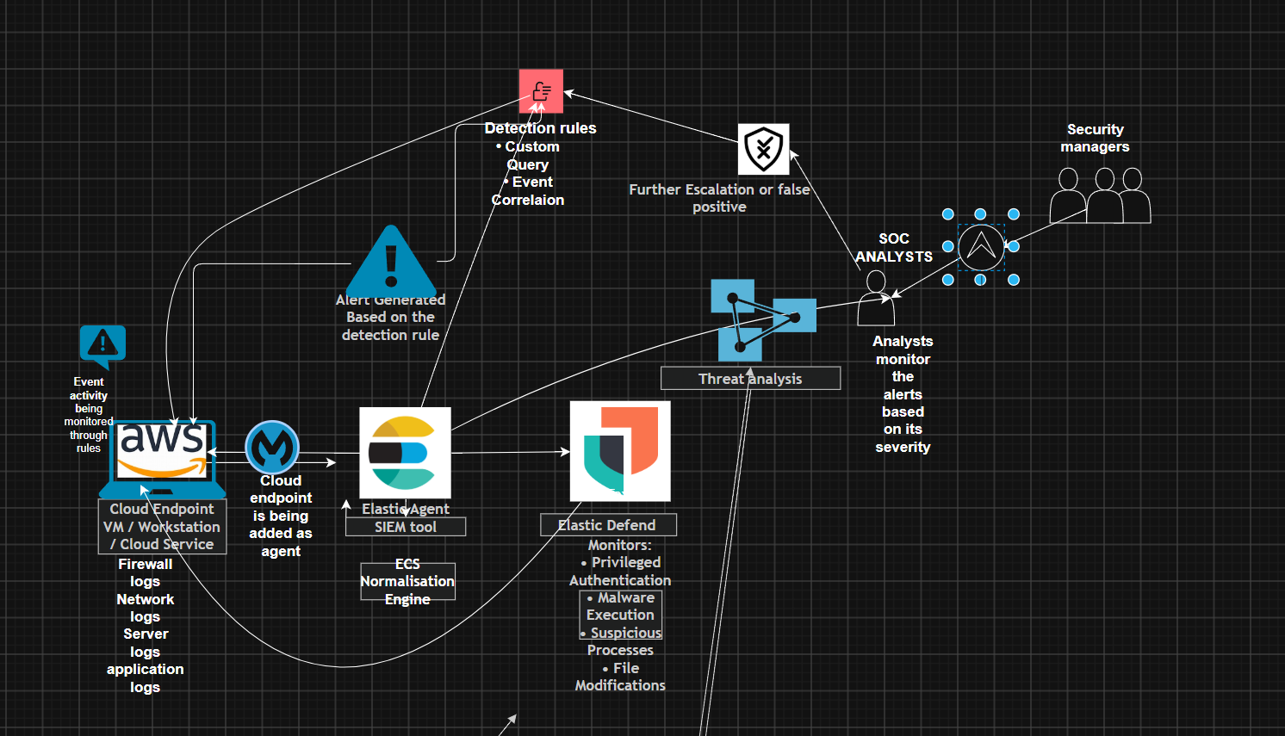

  - Proposed model
Overview of the proposed model

The proposed model extends the existing elastic SIEM workflow in security operations centers by integrating AI workflow automation using the Tines AI workflow automation tool and zero-trust endpoint protection solution with ThreatLocker. This proposed model preserves the standard stages of security telemetry collection, log normalization, point monitoring, and threat detection by inducing intelligent alert orchestration and preventative endpoint protection, reducing the analyzed workload while also strengthening organizational security.

- Data Collection

Similar to the traditional SOC workflows, the proposed model begins with collecting endpoint telemetry data from cloud endpoints such as Amazon EC2 virtual workstations and servers. The elastic SIEM includes a series of security events and is an elastic agent that listens for telemetry data from cloud endpoints; this agent is installed on the cloud endpoint to transfer the telemetry data to the elastic SIEM dashboard.

The telemetry data consists of various security events and logs. The Elastic Common Schema standardizes the telemetry data, which includes a series of security events. into the Elastic Common Schema.

- Data normalization through ECS and endpoint monitoring

Once the endpoint telemetry data is collected from the cloud endpoints, the telemetry data is normalised through its definitive translation standard process carried out by the Elastic Common Schema, an open-source specification defining the field names, data types and structures for storing telemetry data in Elastic SIEM. The main purpose of data normalisation is to ensure that the security data from multiple cloud endpoints follows a common structure for correlation and analysis.

The endpoint is then integrated with Elastic Defend, which continuously monitors endpoint visibility from following activities
- Privileged authentication
- Malware execution
- Suspicious process creation

At this stage, the workflow looks like

Cloud Endpoint
│
Elastic Agent
│
Elastic Common Schema (ECS)
│
Elastic Defend
│
Elastic SIEM

- Detection rule setup

As the endpoint monitoring has been successfully established and deployed, security analysts further configure custom detection rules within Elastic SIEM to identify potential security threats and generate alerts for them.
In the proposed model, the detection rule for custom queries is created using Windows event ID 4672, which explains privileged activity detected when logged into a Windows endpoint. This privileged activity refers to an administration login event carried out by a user. This rule continuously fires whenever incoming security telemetry indicates a suspicious attempt on the Windows endpoint.

The detection rule was configured as per the following

Configuration Parameter | Description
Rule Type | Custom Query Rule
Detection Event | Windows Event ID 4672
Purpose | Detect privileged administrator logon activity in windows endpoint
Severity based on risk | High 70/100
Rule Action | Trigger Webhook Connector

- Webhook integration

Once the detection rules have been set and are ready to fire
This proposed model implements an AI-assisted intelligent orchestration workflow by integrating a SIEM webhook connector into the Tines AI workflow automation tool.
The Elastic SIEM dashboard contains connectors that could be added to cloud endpoints to automate an action from the detection rule that fired, which could possibly indicate a threat.
The webhook connector here establishes a secure connection between Elastic SIEM detection rules and the Tines workflow automation platform using the URL generated in Tines' workflow window.
So, whenever the event ID 4672 detection rule is activated, the Elastic SIEM automatically sends the alert details as an HTTP POST request to the Tines webhook integration.
The alert payload consists of the following information, such as rule name, rule description, alert severity, timestamp, and endpoint information.
The core principle of this step is that it eliminates the need for analyzing, manually exporting, or transferring alert information between security platforms.

- AI Workflow Automation Through Tines

This proposed model induces Tines, an AI workflow automation tool that employs modular, sequential workflows, which turns SIEM security warnings into structured investigation summaries. After ingesting and correlating logs from cloud endpoints, the system processes this data to enhance security measures. The logs are supplemented with threat data and LLM-AI analysis, thus preventing anomalies in real time.

The proposed model induces a workflow consisting sequential automation actions as follows:

Webhook action
This serves as an entry point for the workflow by receiving the HTTPS request that contains the alert payload transmitted from the webhook connector in Elastic SIEM. The alert information is passed on to the next stage for analysis.

AI analysis action
This process involves intelligent processing carried out by AI through a large language model that provides contextual decision support in the following ways:

- a summary of the alert payload
- identifying the suspected behaviour

Email notification
following the AI analysis. The email notification generates an alert summary that includes detection rule information.
- alert summary
- detection rule information
- investigation recommendation steps

- AI-Assisted Analyst investigation

The proposed model helps SoC analysts evaluate alerts intelligently using the contextual information provided by the AI workflow tool Tines, supporting them in making quick decisions based on the given structured recommendations rather than just investigating raw event logs.
Alert fatigue will no longer be a problem in SOC workflows, as repetitive investigation tasks will be automated so that analysis can focus on higher-value incident response activity.

- Zero Trust Architecture though Threatlocker for endpoint protection

Considering AI workflow automation as one component, the proposed architecture induces an additional defensive layer on the other side by deploying zero trust architecture through a zero trust endpoint software solution tool called ThreatLocker.
ThreatLocker follows a default-deny security principle throughout its workflow; each application and process is explicitly authorised before execution, highlighting a transition from traditional reactive approaches to proactive prevention mechanisms that strengthen clouds and endpoints against emerging threats in the global landscape.

threatlocker consists of following zero trust capabilities

Zero Trust Capability | Purpose
Application Allowlisting | Only authourised applications are permitted to execute.
Default-Deny Policy | Blocks all unauthorised software unless explicitly allowed.
Ringfencing | Restricts application behaviour and limits interaction with critical resources such as PowerShell, scripts, and network resources.
Elevation Control | Provides temporary administrator privileges without permanently assigning local administrator rights.
Storage Control | Controls access to USB devices, removable media, files, folders, and shared storage locations.
Unified Audit | Records application activity, policy enforcement, and endpoint events for auditing and compliance.
Considering the scenarios where the detection rules are misconfigured or produce false positives, ThreatLocker can actively stand here as an additional layer of protection from preventing an unauthorized execution based on its zero trust policies.

Let's take, for example, when an attacker successfully gains initial access to the cloud endpoint through credential theft following a privileged login activity. ThreatLocker can block an authorized user's applications and processes and restrict PowerShell execution through the help of ring fencing, enforcing the least privilege access principle and securing the cloud endpoint.
The proposed architecture combines detective controls carried out by Elastic SIEM and Tines with preventative controls forced by Threat Locker, creating a defense-in-depth approach to cloud endpoints.

6.5 Demonstration of the design

This section represents visual demonstration of the design in two phases: phase 1 explains AI-driven workflow automation in SIEM platforms using the Tines AI workflow tool, while phase 2 focuses on understanding zero-trust architecture, which is also combined with AI-driven workflow automation. The objective of dividing the design architecture into two phases is to progressively explain the proposed solution, starting with the automation of security operations in SIEM platforms and then extending the architecture to include preventive zero-trust security controls.

Phase 1
Phase one demonstrates the AI workflow automation component, illustrating how security telemetry data collected from cloud endpoints within SIEM platforms is automated and intelligently correlated using the Tines AI workflow automation tool. This phase emphasises the entire automation process, commencing with the collection of custom detection rules for endpoint telemetry data, followed by the integration of webhooks to enable AI-assisted alert analysis and the automation of email notifications. These components collectively provide a structured investigation summary for the analyst.

The proposed model demonstrated in phase 1 explains the workflow design, beginning with the deployment of a cloud endpoint hosted on an Amazon web service. An EC2 instance running Microsoft Windows Server 2025 as a host cloud endpoint is monitored within the proposed environment of AWS cloud services, continuously generating endpoint telemetry data, including Windows security events, firewall server logs, network logs, and application logs throughout the proposed architecture.
The endpoint telemetry generated from the cloud endpoint is collected by Elastic. The Elastic SIEM tool contains an Elastic agent that can be deployed on any cloud endpoint or virtual machine to act as an active listener for telemetry and forward it to Elastic SIEM. As the endpoint telemetry data is transmitted to Elastic SIEM, it is standardised using the Elastic Common Schema, which normalises the data to ensure that security events originating from cloud endpoints follow a consistent structure suitable for correlation and analysis.
The cloud endpoint is also connected to Elastic Defend, which helps detect and respond to threats and better understand what happens on the endpoint before sending the information to the Elastic SIEM dashboard for security review. The telemetry data reaching the Elastic SIM dashboard is segregated through custom detection rules, in this case, events. Windows Event ID 4672 was developed within Elastic SIEM to monitor privileged administrative logon activity from cloud endpoints. Whenever the configured detection rule identifies matching activity and the rule fires, Elastic SIEM automatically generates a high-severity security alert based on the detection rule, providing an analysis to further process the alert. Now, the system eliminates the need for analysts to manually review and transfer alert information between security managers. The proposed model induces intelligent workflow automation through the integration of a web connector in correlation to Tines. Once the event ID 4672 detection rule is fired, Elastic SIEM automatically transmits the alert payload as an HTTP POST request to the webhook endpoint generated within the Tines platform. This webhook establishes secure communication between Elastic SIEM and Tines, eliminating manual alert forwarding while also enabling intelligent automated alert orchestration.
The final stage of the workflow demonstrates transforming traditional alert handling carried out by security analysts into an air-assisted investigation process. Analysts are no longer required to manually correlate logs or prepare investigation notes, while they can just receive structured contextual information immediately after an alert is generated through the help of Tines.This enables faster incident prioritisation and minimises alert fatigue, which is common in SoC workflows, gradually allowing analysts to focus on higher-value security investigations.

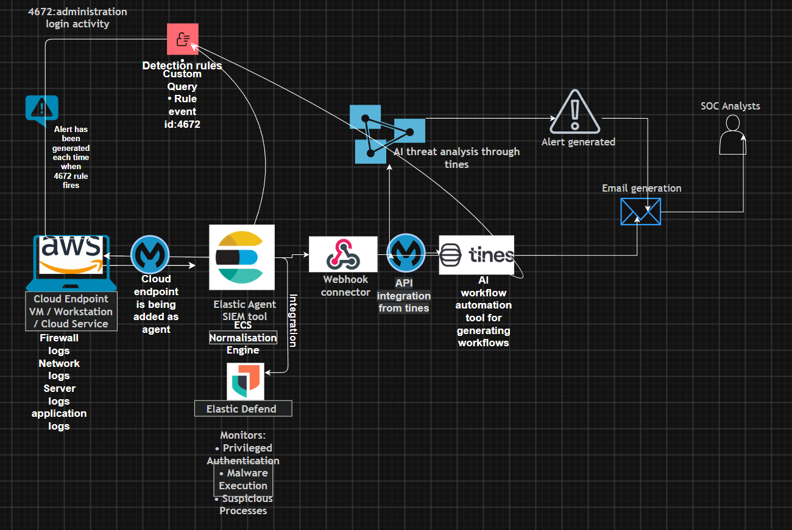

Phase 2: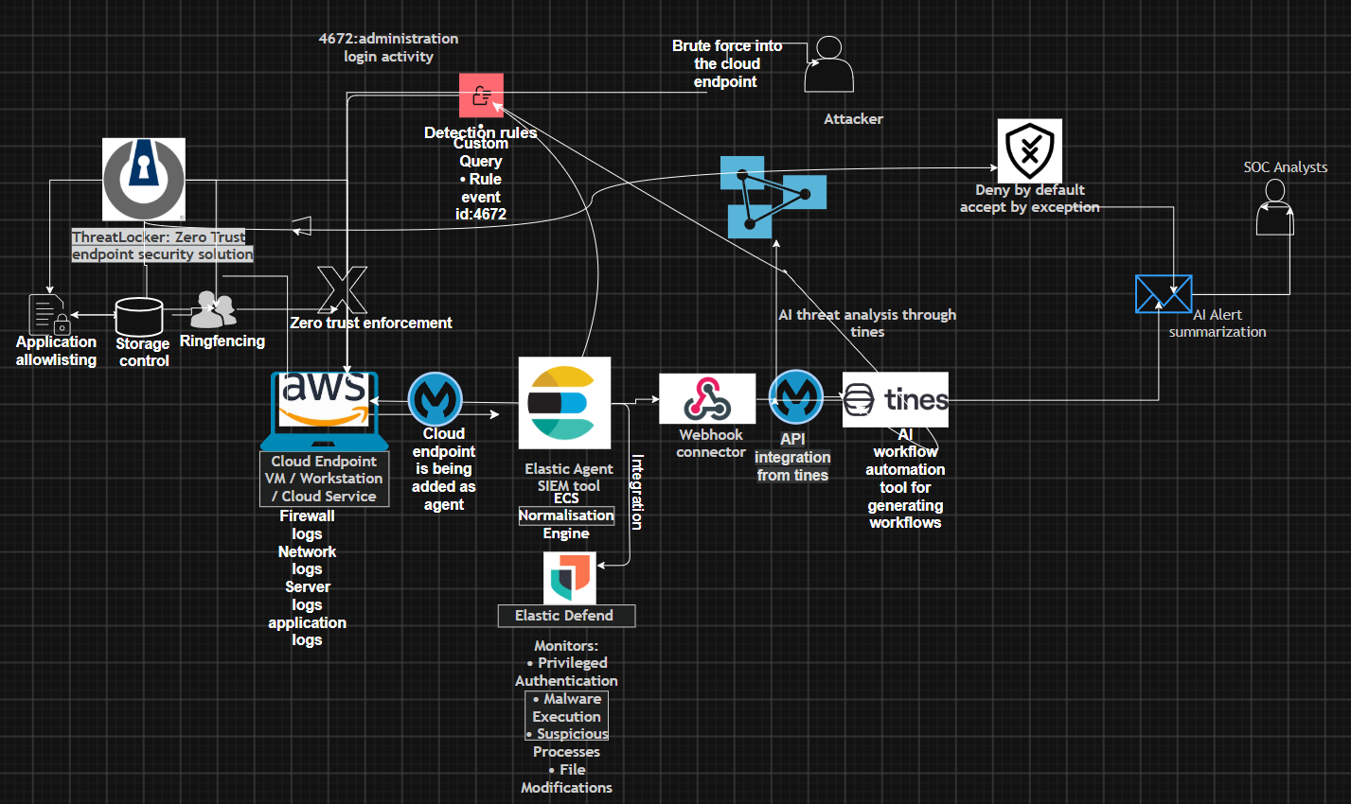
  - Zero Trust Architecture design Overview
Phase 2 of the proposed model induces a zero-trust endpoint protection layer using ThreatLocker. The main purpose of the Zero Trust endpoint design is to enhance the preventative security capabilities of the proposed AI-driven workflow automation architecture. ThreatLocker here acts as an additional layer serving a zero trust protection solution for cloud endpoints, while Elastic SIEM continuously monitors endpoint telemetry to detect abnormal activity. While the first phase focuses on AI-assisted security monitoring through Elastic SIEM and Tines workflow orchestration, stage 2 strengthens the proposed model by inducing preventative controls before malicious activity can execute on the endpoint.
ThreatLocker is a cloud-based software-as-a-service platform that centrally manages endpoint security policies through its dedicated portal. ThreatLocker induces endpoint protection through the ThreatLocker agent, which is installed on the cloud endpoint. Considering this scenario, the ThreatLocker agent would be deployed into an AWS EC2 Windows Server 2025 endpoint to provide kernel-level security enforcement, as shown in the proposed model subhead. The ThreatLocker agent operating at the Windows kernel enables it to intercept application execution requests before they reach the Windows Server 2025 operating system, thereby allowing or blocking all software, ransomware, malicious scripts, and zero-day attacks. The ThreatLocker agent provides prevention against software, ransomware, malicious scripts, and zero-day attacks.
Threatlocker agent demonstration
The ThreatLocker agent works on a zero-trust system that automatically blocks all software and files unless the administrator specifically approves them, unlike traditional security solutions that rely on identifying known threats. rely on signature-based detection mechanisms The zero-trust architectural design follows a default-deny security model that blocks all software scripts and executable files by default and allows only those explicitly approved by the administrator to run on the endpoint. Through this process, it also verifies whether predefined security policies have explicitly authorized an application. explicitly authorized by predefined security policies. Applications that do not satisfy these policies are automatically prevented from executing any processes, which reduces the attack surface level.
The threatlocker agent consumes minimal system resources and also ensures continuous protection when installed locally. The ThreatLocker portal demonstrates the security policies that the agent synchronizes with the cloud endpoint and stores locally. The policy enforcement process The policy enforcement process continuously ensures uninterrupted zero trust protection, even if the cloud endpoint temporarily loses communication with the cloud platform. continuously, even if the cloud endpoint temporarily loses communication with the cloud platform, ensuring uninterrupted zero trust protection.
Considering a scenario in which an application attempts to execute, the threat locker agent evaluates whether the application has been given explicit authority rights because of approved security policies; however, if the application is unknown and does not match the approved policy, its execution is automatically blocked.
The proposed workflow can be represented as
- if the user attempts to execute an application
- threat locker agent intercepts execution request
- application identities verified against approved policies
- Approved applications are allowed to execute.
- Unknown applications are denied by default and recorded.
- Security events are then forwarded for further monitoring and analysis.

Default deny application control
Among the Threatlocker controls, there is a default deny policy that operates within the default-deny security model. Unlike traditional security approaches that allow applications to execute unless identified as malicious, Threatlocker follows an allow-listing approach where applications are denied by default unless explicitly approved, considering that they are denied in the first place.
Within this proposed architecture, an attacker attempts a brute force attack against the cloud endpoint. It may help the attacker successfully obtain valid credentials; however, gaining access does not automatically provide execution privileges. Any malicious payload script or executable command prompt introduced onto the system must first pass the verification process of the Threatlocker application.
The verification process may resemble the following steps:
Application Execution Request
|
↓
ThreatLocker Policy Verification
|
-------------------
| |
Approved Unknown
| |
Allow Deny & Log

These mechanisms provide protection against unknown malware, ransomware, and zero-day threats.
Threatlocker prevents attackers from progressing further by restricting execution capabilities, based on the detection rule with event ID 4672 that identifies abnormal privileged authentication activity.

Ringfencing Feature
Ringfencing is a unique feature in ThreatLocker that governs the behaviour of authorised applications after execution. Ringfencing acts as a principle of least privilege inside the zero-trust architecture by restricting instructions between applications, administrative utilities, and network resources.
Within the proposed model, ringfencing acts as a defensive layer, enforcing Threatlocker's application control by ensuring that applications can only perform activities explicitly permitted by organisational security policy. This prevents legitimate applications from being abused to perform actions outside their intended operational scope.
Phishing campaigns and zero-day exploits Modern cyber attacks, such as phishing campaigns and zero-day exploits, simply abuse trusted applications within the operating system. This means that without a behavioural restriction, an attacker can laterally exploit legitimate applications to download additional malware, establishing persistence and credential theft within the network. Ring-fencing directly stops harmful software from entering applications and causing them to act strangely on individual devices, which helps stop the attack from spreading further. Even if an attack keeps trying to break the ring-fencing rules, the threat locker keeps track of what happens and continues through a unified audit, which helps Elastic SIEM and the Tines AI workflow connect endpoint policy violations with other security data for investigation and response.

Storage Control
Storage control acts as an additional preventative security layer by restricting read, write, and execute permissions for external storage drives, network shares, and other removable media. That means administrators can define granular policies for department access restricted only to approved devices while blocking unauthorized storage devices from interacting with the endpoints.
Storage control operates hand in hand alongside threatlocker’s application control, and ring fencing to reduce the endpoint attack surface before malicious activity reaches the detection phase.

  - Purpose of the model with justification

The proposed model extends traditional elastic SIEM SOC workflows by integrating AI-driven workflow automation using Tines' zero trust endpoint protection and ThreatLocker to automate SOC activities, intelligently improve investigations, efficiently reduce analyst workload, and provide an additional preventative defensive layer of security for cloud endpoints. The proposed architecture fulfils security principles such as the principle of least privilege access and defence in depth.

Justification:
Traditional SOC Limitation | Proposed Enhancement | Justification
Manual alert investigation | Tines AI workflow automation | Automates repetitive investigation tasks, reducing analyst workload while accelerating the initial triage process.
Alert fatigue caused by high alert volumes | AI-generated alert summaries and investigation recommendations | Assists security analysts in prioritising critical alerts more effectively, improving decision-making and reducing investigation time.
Manual transfer of alert information between security platforms | Webhook connector integration | Eliminates the need for manual intervention by automatically forwarding alerts from Elastic SIEM to the Tines workflow.
SIEM platforms primarily provide detective security controls | ThreatLocker Zero Trust endpoint protection | Introduces preventative security controls that proactively block unauthorised applications and malicious activities before system compromise occurs.
Detection rules may generate false positives or fail to identify unknown threats | Application allowlisting, Ringfencing, and Default-Deny policies | Provides an additional layer of endpoint protection by preventing unauthorised execution, even when detection mechanisms are bypassed or ineffective.
Longer incident response times | AI-assisted investigations and automated notifications | Accelerates incident response by reducing Mean Time to Detect (MTTD) and supporting faster Mean Time to Respond (MTTR) through workflow automation.

6.6 Layered Design
Layer 1- Cloud Endpoint
The first layer is referred to as the cloud endpoint, involving the deployment of an EC2 instance on AWS running Microsoft Windows Server 2025.
This server serves as the monitored endpoint, identifying, detecting, and listening to generated logs.
This endpoint generates telemetry that includes:
Windows security logs
User authentication logs
Privileged account activity
System events
Process execution events
Endpoint security events
The primary source of data throughout this research is the cloud endpoint.
Layer 2- Endpoint Detection and Response
The second layer consists of tools for managing security information and events, namely Elastic Agent and Elastic Defend.
The Elastic Agent acts as a listener for Windows Server 2025 logs through Elastic Fleet.
The main purpose of the Elastic Agent is to continuously collect telemetry from Windows Server 2025 and transmit security data to Elastic SIEM for processing.
Elastic Defend enhances the capabilities of Elastic Agent by incorporating Endpoint Detection and Response (EDR) functionality, which improves endpoint security through the collection of the following:
Security event logs
Process activity logs
Authentication events
Network connections
Endpoint behavioral data
Threat detection telemetry
The combination of Elastic Agent and Elastic Defend centralizes the monitoring mechanism to observe security events that occur within the cloud endpoint in real time.
Layer 3- Security Information and Event Management
This layer serves as the central analysis platform responsible for:
Log aggregation
Alert generation
Security monitoring
Detection rules are added in this phase to automate the threat detection process across the endpoint by running queries against log indexes.
This research selectively uses a custom detection rule based on Windows Event ID 4672. The Windows Event ID 4672 rule is used to detect special administrative privileges assigned to each new logon session. This rule frequently monitors privileged account activity occurring on the endpoint. When triggered, the rule automatically generates an alert and displays it on the dashboard.

Layer 4 -AI-Driven Workflow Automation
The fourth layer consists of Tines AI Workflow Automation. Tines AI Workflow Automation is an automation platform that allows users to create workflows using a drag-and-drop interface. Each story represents a workflow consisting of connected actions that are performed automatically.
This research uses Tines to automate incident response actions for alerts related to privileged access detected on the endpoint.
Layer 5 represents a Zero Trust endpoint solution.
This layer signifies Zero Trust security, serving as the final pillar for securing the endpoint.
The concept of a Zero Trust architectural framework is implemented through a software solution called ThreatLocker, which operates on the principle of "Never Trust, Always Verify," ensuring that every application, process, script, and user action is continuously evaluated before being permitted to execute.
This platform introduces multiple security controls, including:
Application allow-listing
Ringfencing
Privileged access management
Storage device control
Zero Trust policy enforcement
While Elastic Defend continuously monitors endpoint activity and detects suspicious events, enabling AI workflow automation to perform its functions effectively, ThreatLocker acts as a preventative security layer that proactively prevents unauthorized behaviour at the endpoint.
In cases where Event ID 4672 fails to detect an attack, the AI workflow automation tools fail to deliver the intended response, or an attack bypasses the security mechanisms established within the first four layers, this fifth layer acts as an additional pillar of defence, extending security through the implementation of Zero Trust principles.

Chapter 7 Implementation

7.1 overview Step by step setup of the project
The following section presents a comprehensive overview of the research work.

A cloud-hosted Windows endpoint is deployed in Amazon Web Services (AWS). This is the first step in the installation of the test procedure. The Elastic agent is installed on the same endpoint after it becomes operational to collect and direct elementary and forward security events to Elastic SIEM as part of its functionality.
This step aims to further enhance the visibility of endpoints. The deployment of Elastic Defend is done to provide capabilities for endpoint detection and response. Within Elastic SIEM, security events that were collected from the endpoint were analyzed using detection logic that was truly customized upon request.
Because of this deployment, detection rules have been implemented to identify and keep track of administrative login activity on the Windows Server 2025 endpoint.
Once the detection phase is complete, a webhook connector is added from among the Elastic SIEM connectors and integrated with a workflow automation tool that uses artificial intelligence called Tines. This tool will smartly automate SOC workflows by allowing security alerts from Elastic SIEM to be generated based on these detection rules. Tines will then send investigation suggestions to the SOC analysts by email, helping them take the next steps and eventually create a better SOC workflow model that keeps cloud endpoints safe from threats.

7.2 Deploying the AWS Endpoint
Deploying the AWS Endpoint In the initial stage of the project, a cloud-hosted Windows endpoint was created to serve as the monitored system throughout this research.
The following configurations were made to deploy the virtual machine: -
Operating System: Microsoft Windows Server 2025 base Amazon Machine Image - Computer Resources: m7i-flex.large
Key Pair: Test Purpose
Storage: 30 GB SSD gp3

7.3 Installing Elastic Agent
Once the Windows server endpoint was successfully deployed, the next step was to deploy the Elastic SIEM security event management tool on the Windows server to monitor the telemetry logs from the endpoint.
The following steps were taken to add the Windows server endpoint as an agent in the Elastic SIEM dashboard: Assets → Fleet → Agents → Add Agents
The agent was named "Policy 7."
This agent policy included system integration commands that facilitated the collection of operating system logs and host telemetry across various operating systems, including macOS, Windows, Linux, and Bash.
Windows was chosen as the target platform, allowing the necessary PowerShell integration commands to be copied and pasted for registering the endpoint with Fleet. After logging in via RDP, the Windows server endpoint was activated, and the following commands were entered into PowerShell to install the Elastic SIEM tool.
The installation was successful; upon refreshing the fleet dashboard on the Elastic SIEM page, the agent status displayed as healthy, confirming that the agent had been properly deployed on the Windows server endpoint. At this stage, it was ready to collect event logs and endpoint telemetry and forward them to Elastic.

7.4 Deploying Elastic Defend
The elastic agent was successfully added to the Windows server endpoint, and the Elastic Defend integration for the Windows server endpoint was also added to the Elastic SIEM dashboard.
This integration enables complete EDR mode, which facilitates:
-Endpoint telemetry collection
- Security event monitoring
All data was sent from the Windows server endpoint and collected by the Elastic SIEM tool. Therefore, the Elastic Defend integration was successful in this regard.

7.5 Creating Detection rule
Once the elastic defend was successfully deployed, custom detection rules were created for detection purposes.
The purpose of the rule is to detect privileged account logins.
During the process of creating the new rule, a custom query rule was selected and configured to function as an event.
The code "4672" identifies and detects administrative privileges, which represent high-value targets within the host endpoint.

7.6 Integrating Elastic SIEM with Tines
The next objective was to automate the alert processing in Elastic SIEM.
Web connector was selected as the connector type.
The connector was named
“tines_webhook_admin_sign_in”
Within the Tines dashboard, a webhook tool was added to the workflow, which had a webhook URL. This webhook URL was copied and pasted into the Elastic webhook connector configuration.
and configured the connector
HTTP Method: POST
authentication: None
After saving the connector, this connector was attached to the Custom detection rule Event ID :4672 that distinguishes that whenever the detection rule generates an alert, Elastic automatically sends the alert payload to Tines, establishing communication between the SIEM platform and the Tines AI workflow automation.

Buidling The Tines AI workflow Automation
Building the Tines AI Workflow Automation Inside the Tines AI workflow automation dashboard through stories .
Each story contributes to a workflow designed to automate tasks.
This proposed story consists of three main components, forming a complete workflow.
The first component is a webhook action, which serves as the entry point for all alerts received from Elastic SIEM. The webhook URL was copied and pasted into the webhook connector in Elastic SIEM.
The second component is an AI action that was dragged and dropped into the workflow. This AI action receives the alert data from the webhook and processes the information using a custom prompt.
According to the custom prompt, the following instructions were provided in the AI action configuration slide:
-Summarize the alert in one sentence.
- Recommend investigation steps.

The AI action was connected to the webhook action TAG
The final component is an email-sending action, which was also dragged and dropped into the story and referenced by the AI action TAG.
The email-sending action receives the AI-generated output and automatically delivers the result to the analyst's email inbox with the following configurations:
-Recipient address
-Subject
-Body

7.7 Threatlocker demonstration
From the proposed architecture, the threatlocker agent will be deployed on the same AWS Windows Server 2025 cloud endpoint, which will operate at the Windows kernel level. As it resides at the kernel level, the threat locker agent continuously evaluates every application execution request before reaching out to the operating system. It follows a default 9-security model whereby every application and process must be explicitly authorized before execution.
The Threatlocker portal serves as a center of management for configuring endpoint security policies.
The threat locker demonstration is carried out by implementing its zero-trust controls, which are as follows:
- application control
- ringfencing
- storage control
These combined controls work together, aligning with Elastic SIEM and Tines AI, to provide a defense in depth of strategic setup, preventing malicious activity through robust security at the endpoints.

7.8 Implementing application control

Application control is a feature in Threatlocker that will serve as a primary preventative mechanism, allowing every application attempting to run on the cloud endpoint to be evaluated against predefined security policies established by this control.
The implementation of the application control begins when Threatlocker is in learning mode. During this phase, Threatlocker continuously observes the endpoint activity and generates a set of application definitions for application control policies. An application definition refers to a collection of executable file hashes and digital signatures that uniquely identifies an application, and regarding application policy, it specifies whether the application is permitted to execute or authorized to perform an action within the environment.
The Threatlocker compares observed software in the cloud endpoint with its built-in application definitions commonly used, such as Windows components and Microsoft Office. Applications that do not match existing built-in definitions are automatically assigned to custom application definitions based on the software observed during the learning phase. This significantly reduces administrative effort, ensuring that only authorised business applications are identified.

As per the diagram
Application Execution Request
↓
ThreatLocker Agent
↓
Application Policy Verification
↓
Approved Application → Execute
Unknown Application → Blocked and Recorded

This feature in Threatlocker helps us understand that if an attacker successfully obtains administrative credentials through brute force authentication or credential theft, this activity would be detected by Elastic SIEM within the detection rule for Windows event ID 4672, which relates to administrative logon activity. However, even after obtaining privileged access, any malicious executables, such as the PowerShell ransomware binary, or unknown software introduced to the endpoint must first satisfy Threatlocker's application control policy. If no approved application definition exists, the execution request is subject to the default deny policy, which automatically blocks the request before execution and is simultaneously recorded in Threatlocker's unified audit, providing additional endpoint telemetry monitoring and supporting further investigation through the Tines AI workflow.

7.9 Ringfencing Through Threatlocker
Once the permitted applications are authorized through application control, ringfencing serves as a second layer of protection that restricts the behavior of those trusted applications after they have been executed, determining what each authorized application is allowed to do while it is running.
Within this proposed model, a ringfencing policy is configured alongside application control policies to ensure that only authorized applications remain restricted to their intended behavior. Applications are prevented from interacting unnecessarily with Windows administrative utilities, scripting agents, and other applications unless explicitly permitted by a policy.
For example, Microsoft Office may be authorized to execute normal business activity; however, during fencing policies, the model helps prevent applications from launching the PowerShell command prompt, Windows script, or any other administrative tool frequently that could potentially be abused during phishing attacks carried out by attackers today. Violations regarding the ringfencing policy are recorded within ThreadLock Unified Audit.

7.10 Storage Control

The final zero trust component in the proposed model is the storage control.
Storage control policies are configured to regulate read, write, and execute permissions for removable storage media, network shares, and storage resources. These policies are used alongside application control and ring fencing to prevent malware induction and unauthorized data x-filtration before such malicious activity reaches the detection phase.
For example, if an attacker gains privileged access through compromised credentials, he wishes to attempt to introduce maliciousness by using removable media or copying sensitive information to an external storage device. Storage controlled here prevents these actions by predefined organizational security policies restricting the entry of the device with the list of storage control policies.
Any attempt to connect to an unauthorized storage device or violations of storage control policies are recorded in ThreatLocker's unified audit.
By combining application control, ring fencing, and storage control in the ThreatLocker software within the proposed model, multiple preventative security layers are provided, restricting malicious behavior at the endpoint and creating a comprehensive defense-in-depth architecture for securing cloud-hosted Windows endpoints.

Chapter 8 Implementation testing and Demonstration Overview

8.1 Overview
Following the design of the proposed architecture, a complete workflow was tested.
In this section, a practical demonstration of the design model will be conducted to evaluate the functionality of each component as intended within the overall security architecture.
It contains step-by-step demonstrations of the proposed model with screenshots presented throughout this section to provide evidence of the successful deployment and configuration of each component.

8.2 Practical demonstration
In this step, all configured components were reviewed, and the environment was tested.

8.3 Screenshots
This section represents a step-by-step implementation of AI-driven SOC workflow automation through a set of screenshots demonstrating how AWS Cloud endpoint activity is detected by Elastic SIEM, analysed and orchestrated through Tines AI workflow, and transformed into actionable security alerts and investigations. These screenshots provide detailed evidence of how each component was configured and integrated and how these technologies were used together to achieve event generation from cloud endpoint and SIEM detection to webhook-based alert transmission for AI analysis and automated email notification generation.
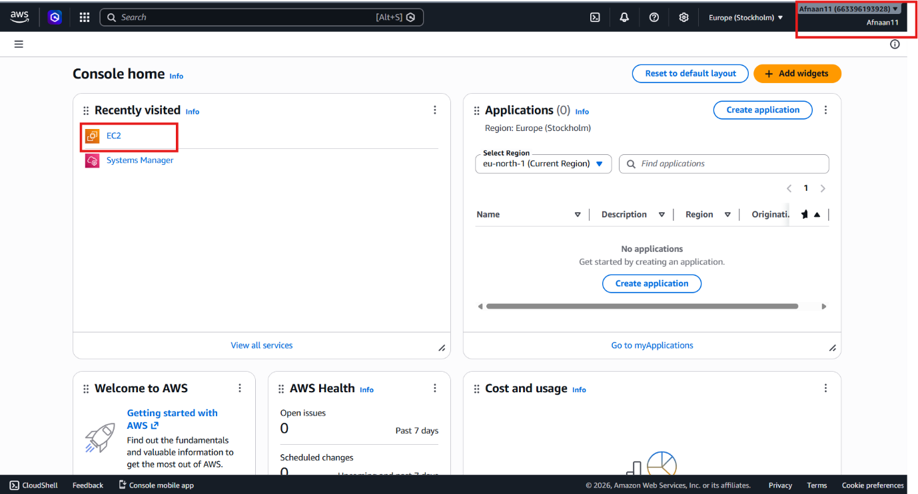

In the above image AWS management console was accessed and EC2 instance was selected as the cloud-based windows endpoint to be deployed in the proposed model
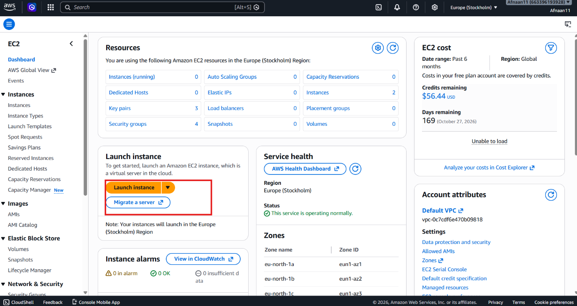
Once EC2 instance service was selected launch instance command was pressed to launch the instance


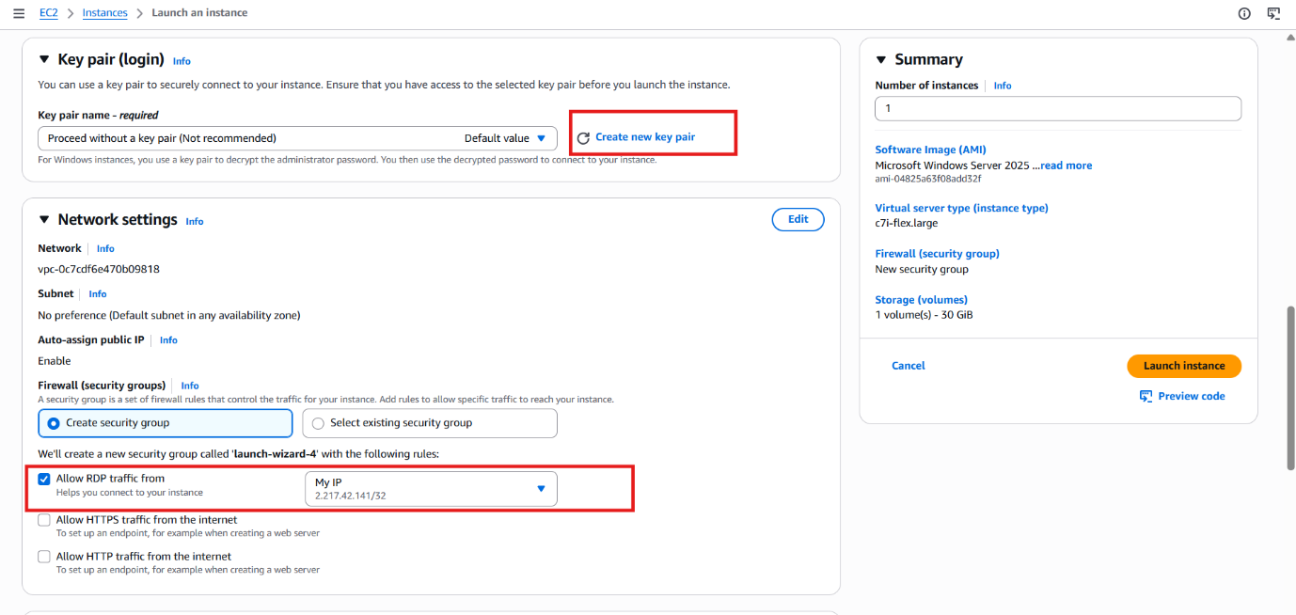
This screenshot shows the EC2 instance configuration made to launch the instance .Instance was created using a key pair and security group
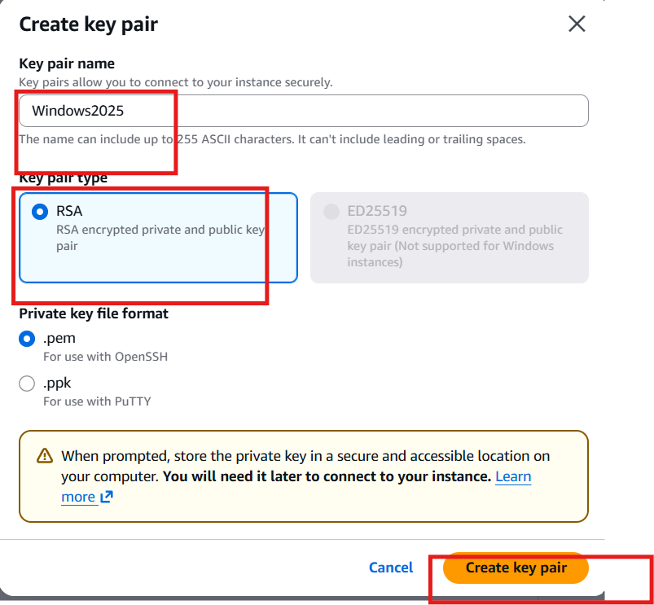
In this step the key pair configuration was made by naming the keypair by its Keypair name, Keypair type and Keypair file format
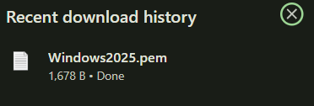
Once the settings were configured the key pair was created successfully and downloaded locally in the system to allow us to connect to the instance through RDP login.
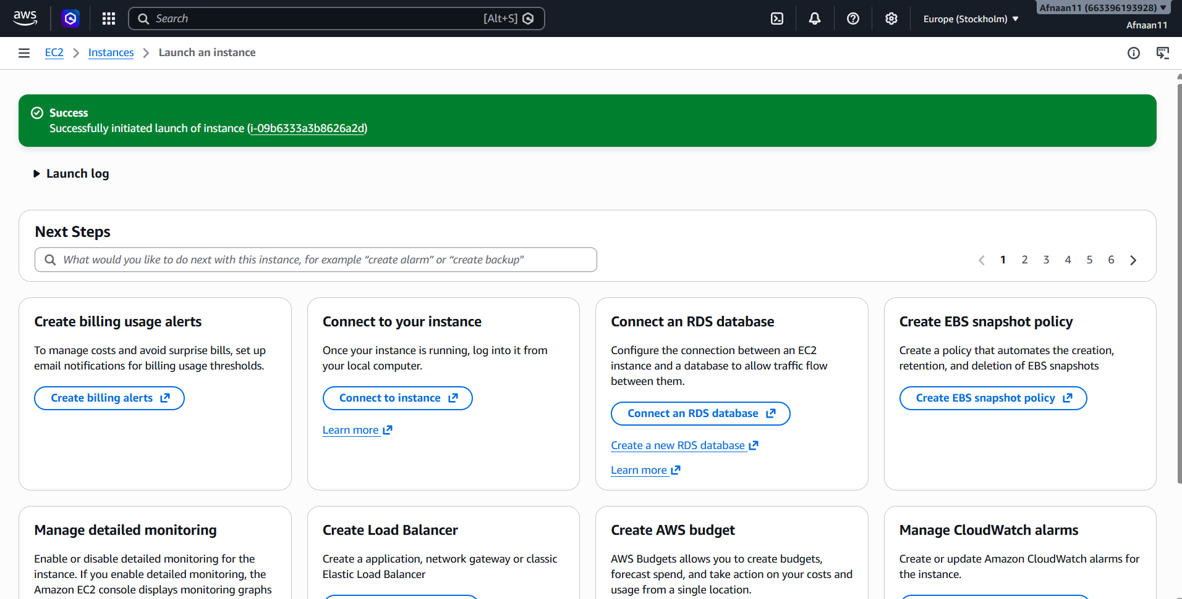

Once the instance was launched successfully , another instance was deployed as the attacking machine
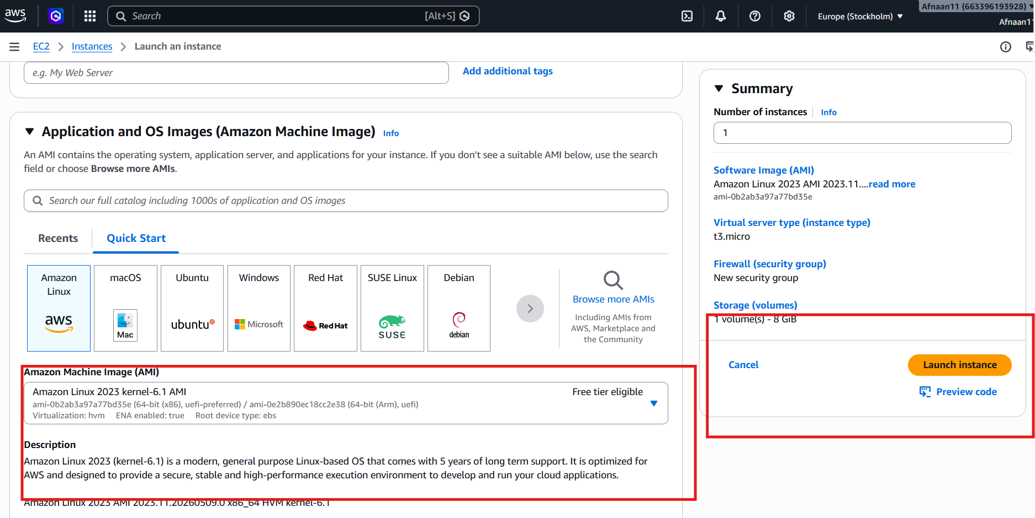
This screenshot shows configuration of the second instance through Amazon Linux 2023 to represent as an attacking machine to test the windows cloud endpoint

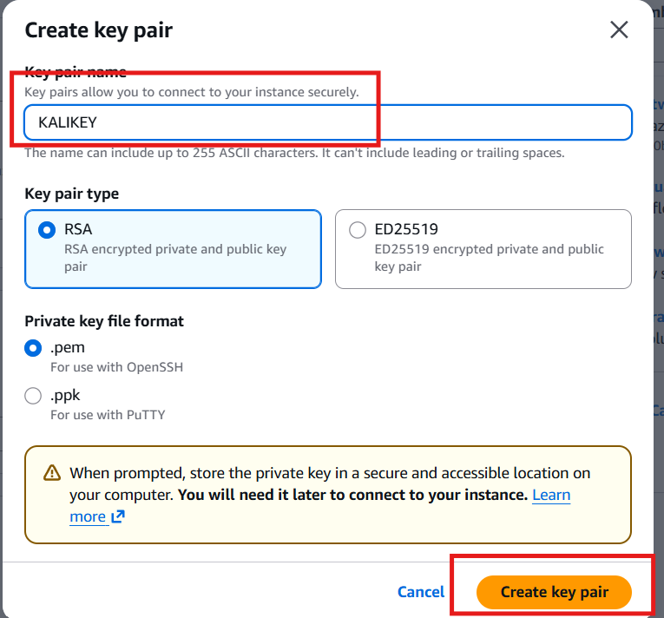
In this step the key pair was created for the Linux machine by giving the Keypair name, Keypair type and Key pair file format to help us deploy the linux instance successfully

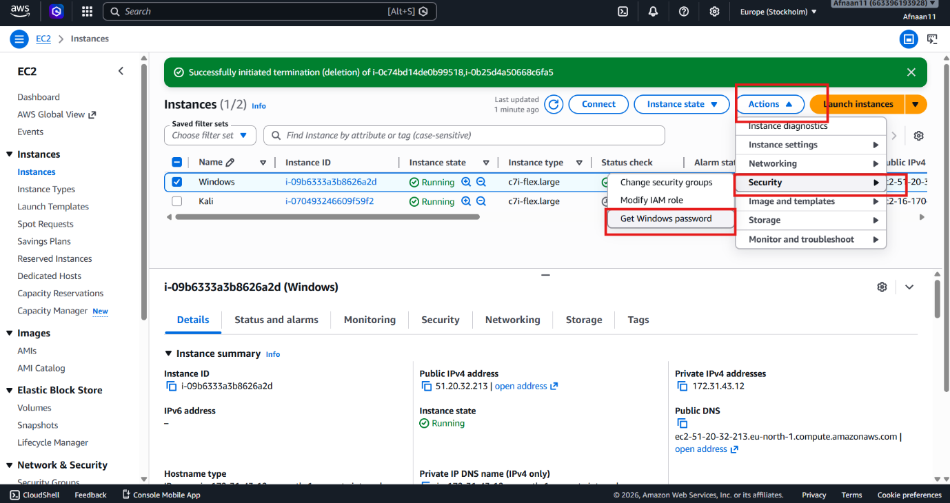
This screenshot shows the Amazon EC2 instances dashboard containing the two instances that were created. To remotely access the windows cloud endpoint the following steps was carried out : Actions → Security → Get Windows Password that retrieves administrator credentials required to login remotely
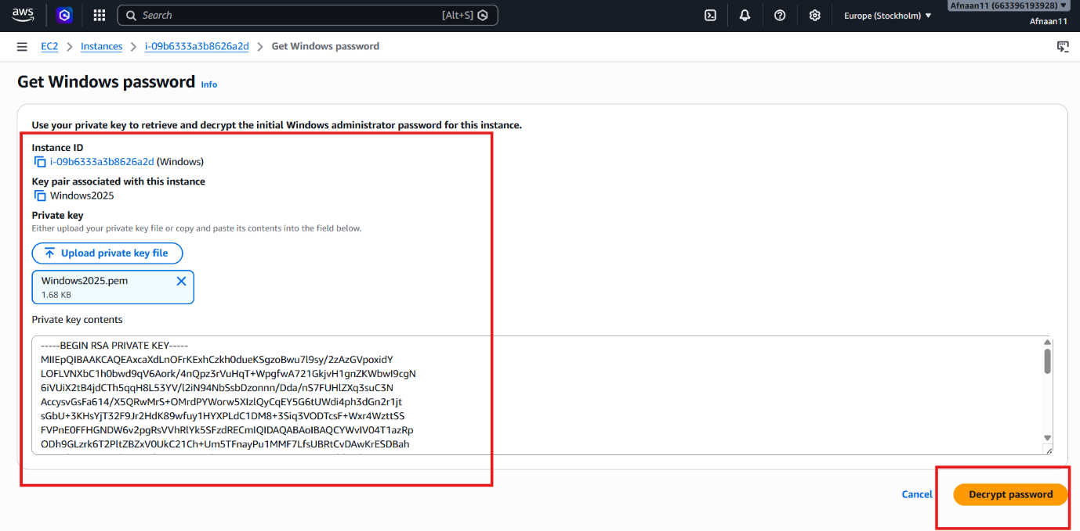
Once “Get windows Password” was selected this interface was opened displaying Instance ID and upload private key file option to upload the previously downloaded private key to decrypt the password of the cloud endpoint.

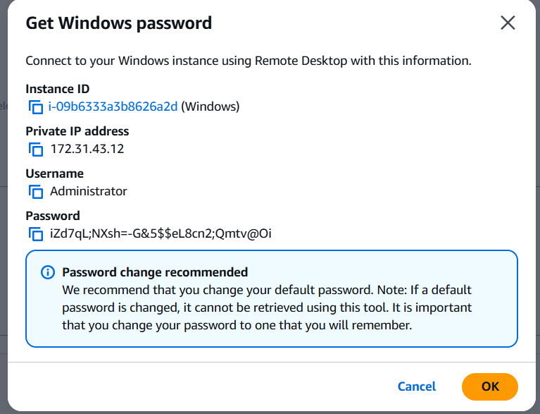
This screenshot shows the following credentials of the windows cloud endpoint
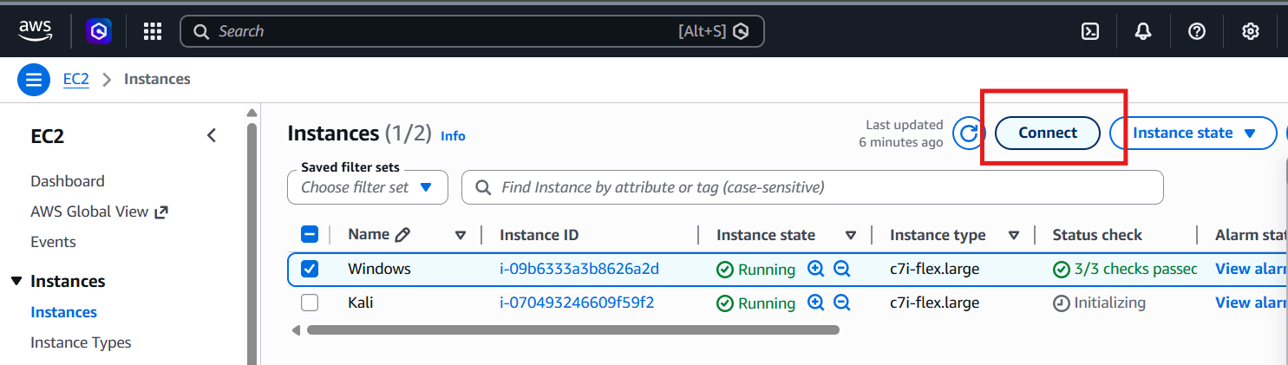

The next step was carried out by connecting the EC2 instance to initiate a remote connection to the windows cloud endpoint

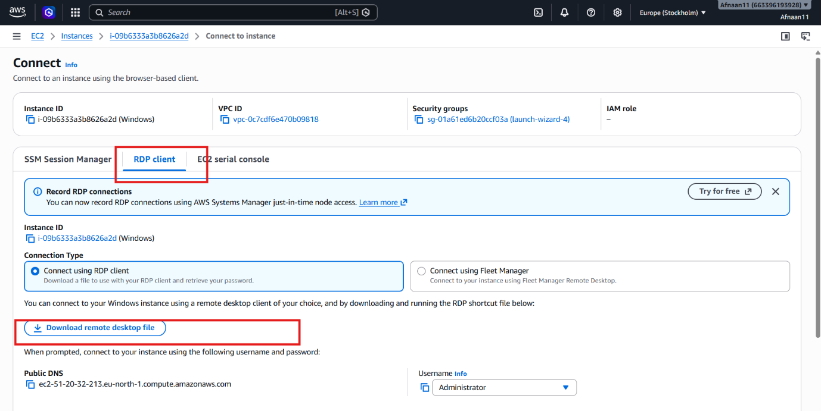
In the next step RDP(remote desktop protocol) client was selected to establish a remote desktop connecting by downloading the RDP file.
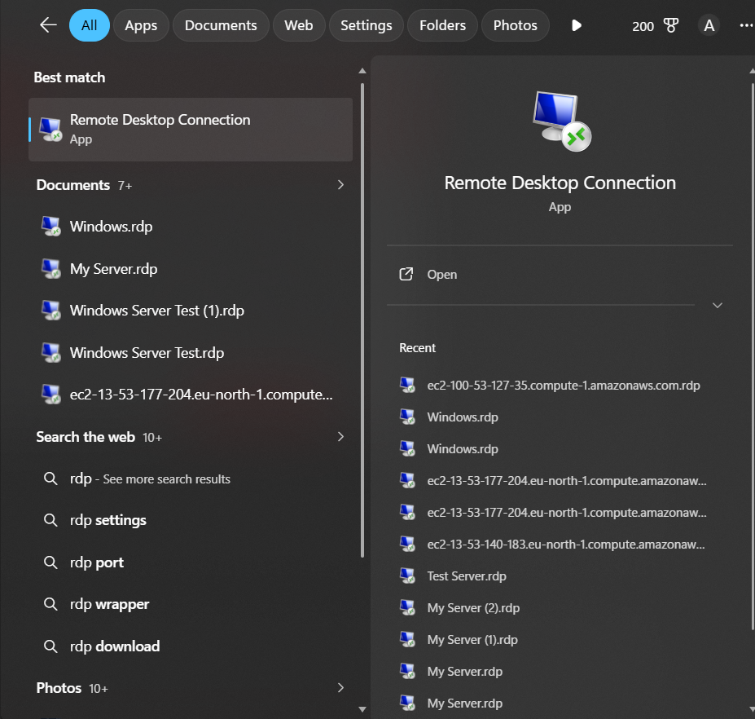
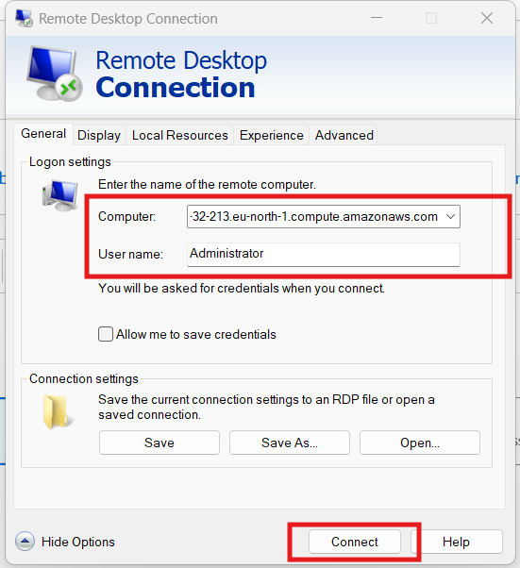
In the following next steps the remote desktop file was opened using Remote Desktop Connection application by simply connecting the downloaded file
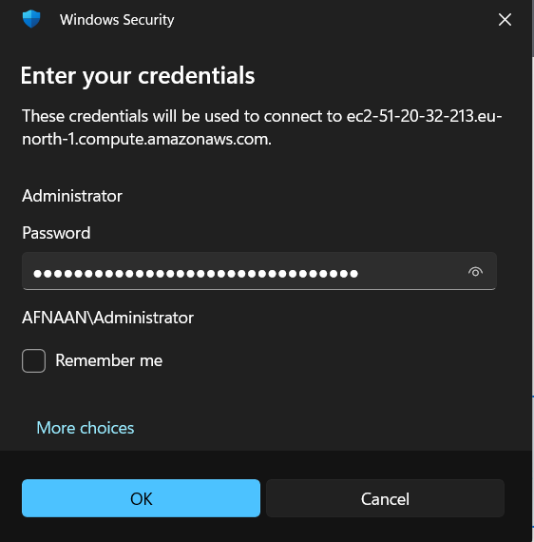
This screenshot shows the credentials entered to connect to the windows cloud endpoint


The Screenshot above shows the cloud endpoint home screen as the RDP connection was successful

After these steps carried out , Elastic integration was done
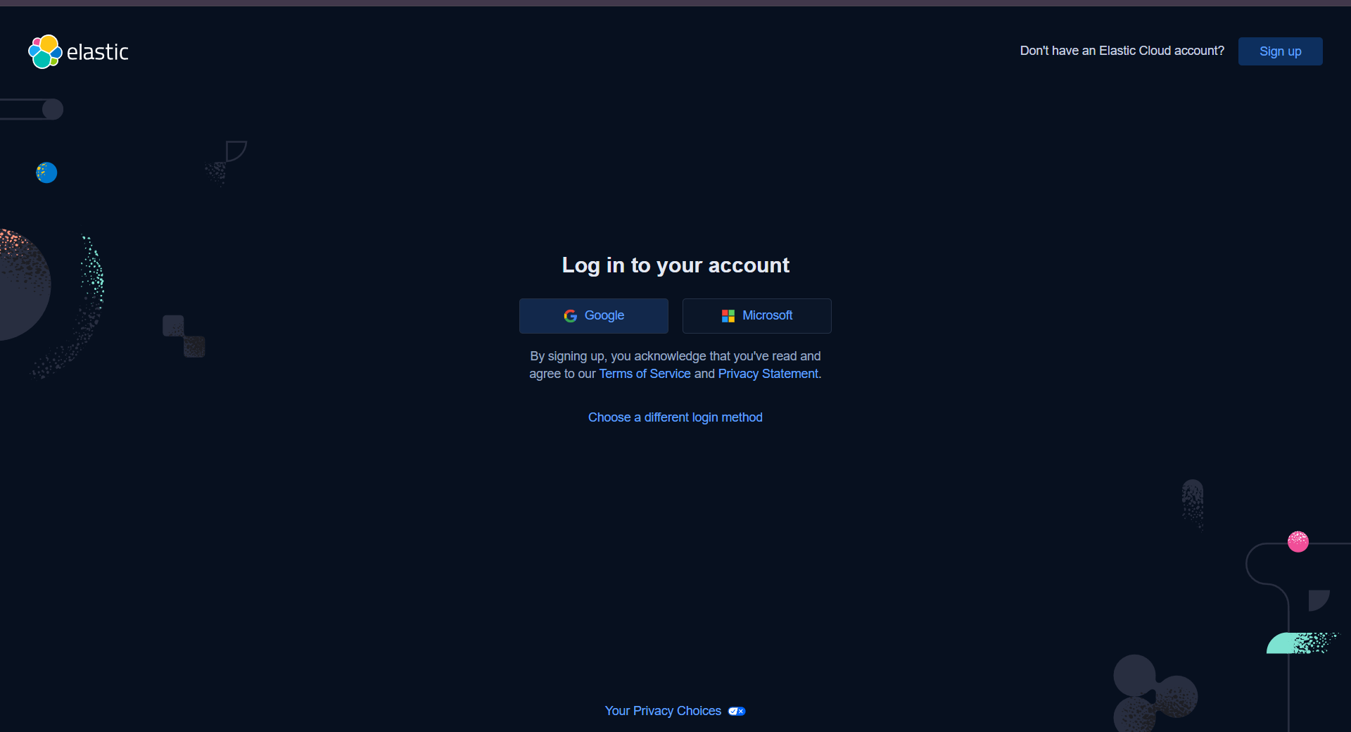

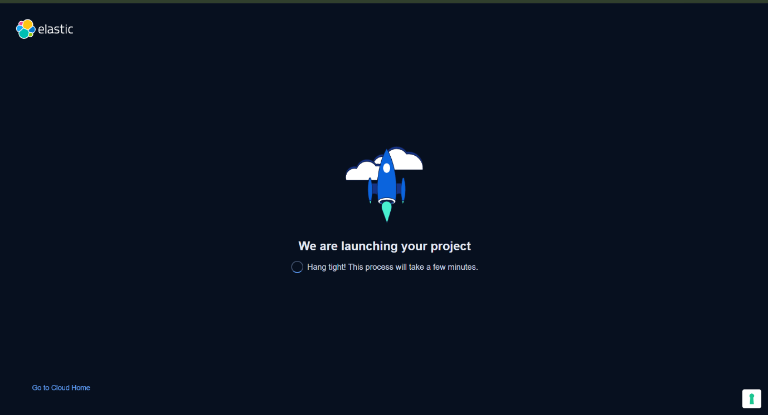
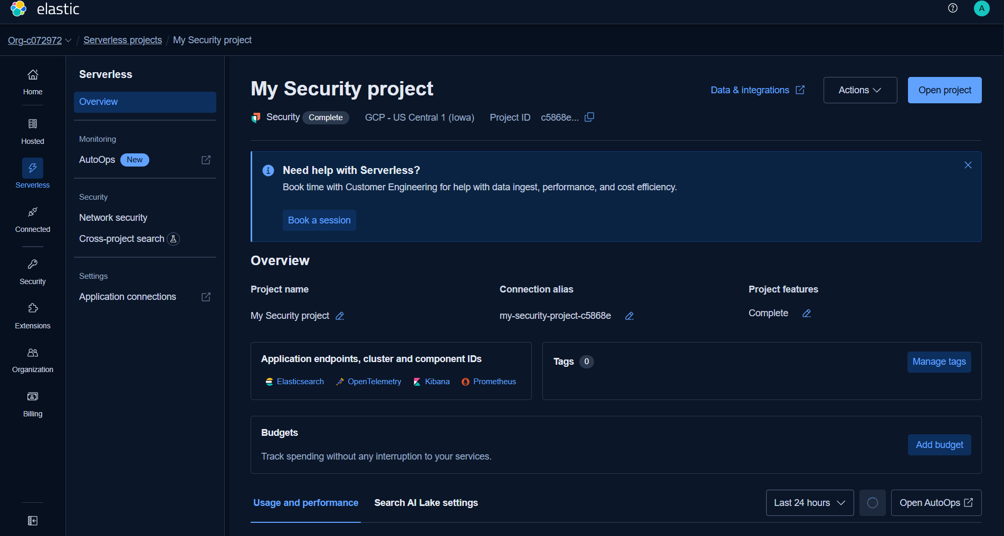

The following three screenshots above showed the Elastic Cloud deployment to provide central monitoring of the cloud endpoint

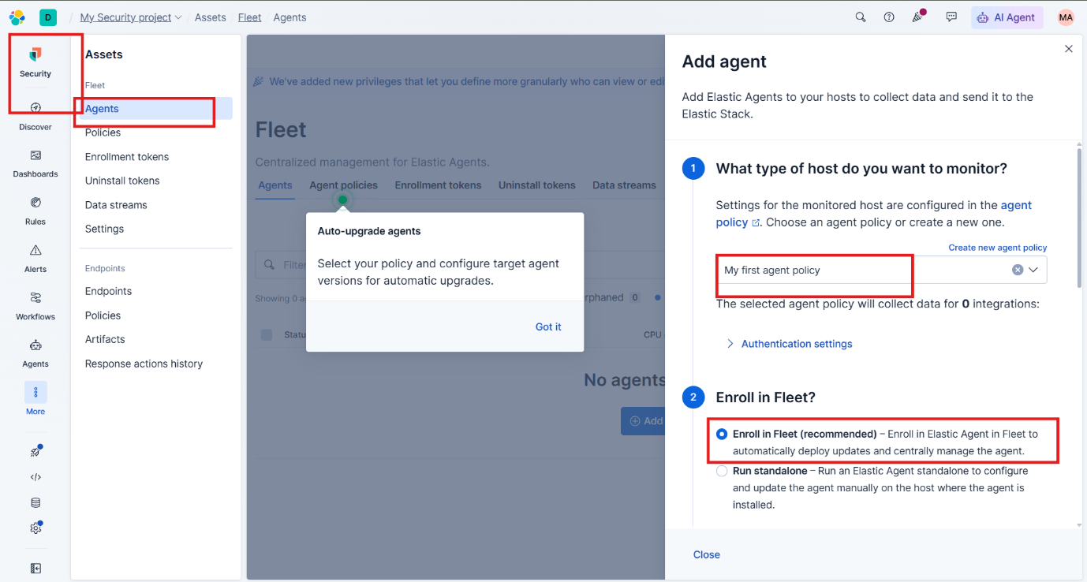
Once the Elastic Cloud deployment was successful elastic agent setup was initiated to enroll the agent into its dashboard feet through following steps Assets → Fleet → Agents → Add Agent

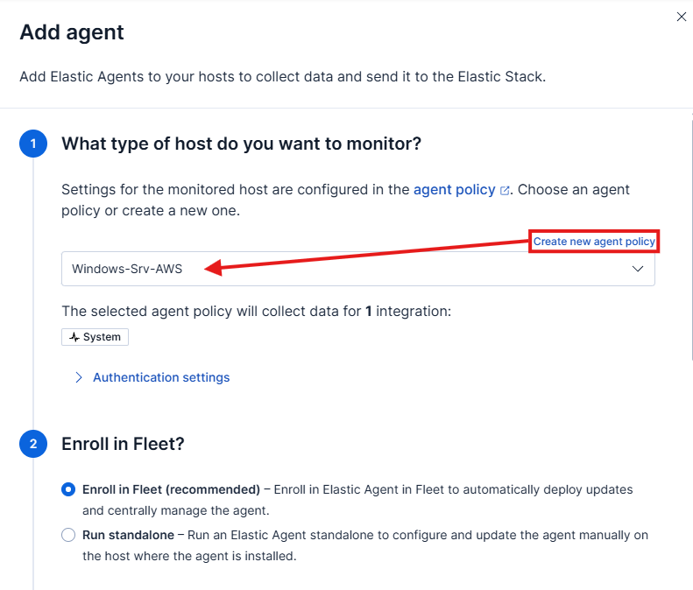

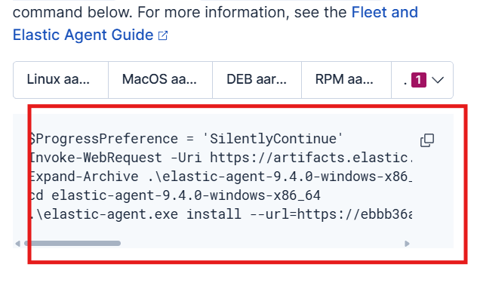
In the following screenshot above the elastic agent configuration was shown by selecting the installation command for Windows operating system
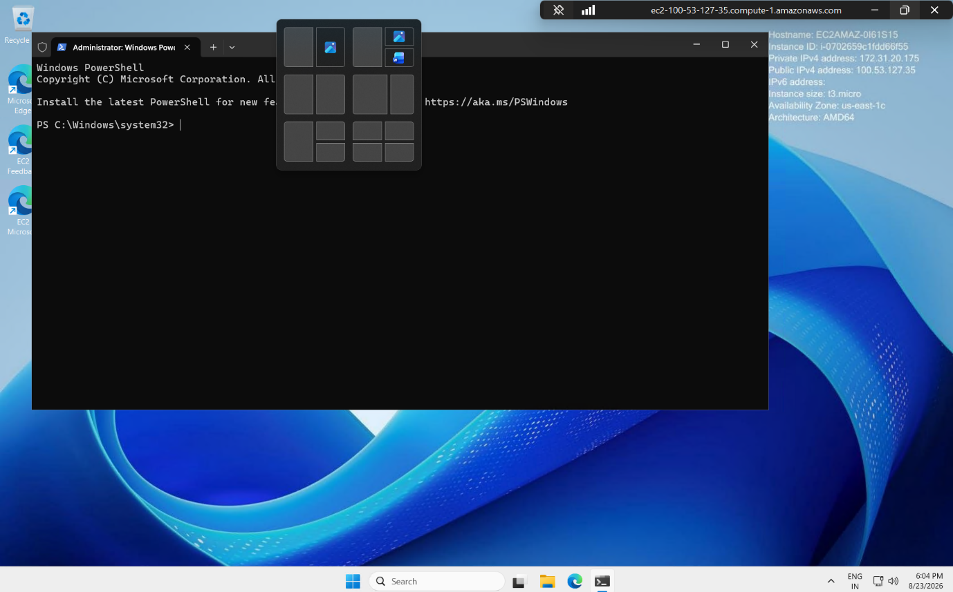

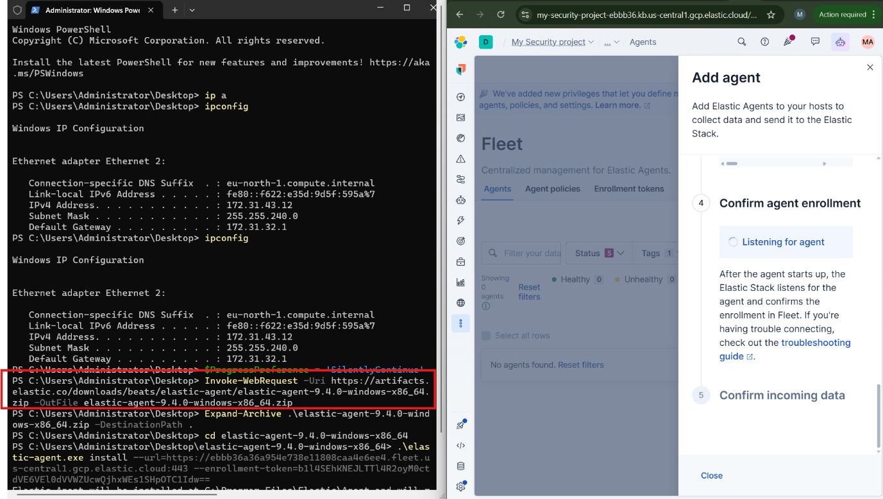
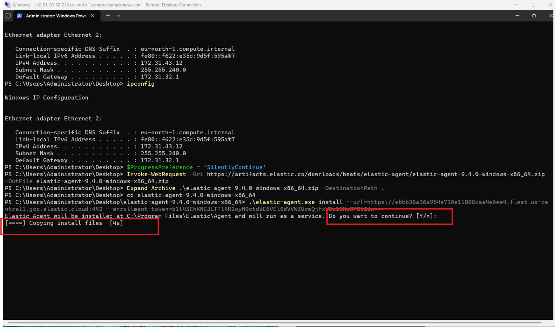
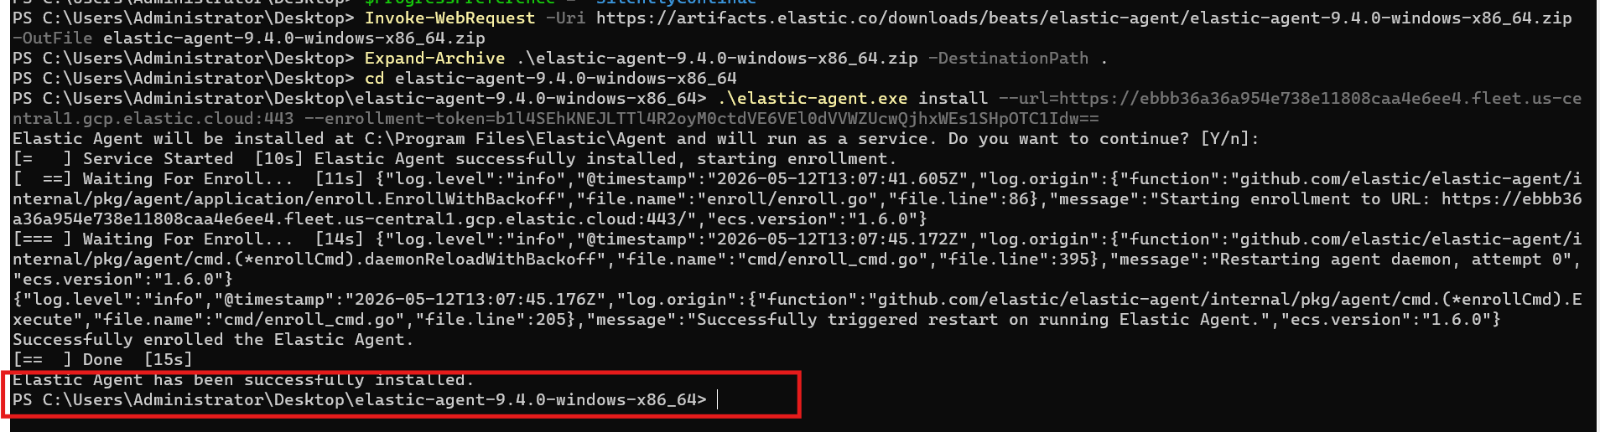

The following screenshots shows the installation of elastic agent in the windows cloud endpoint using powershell by copying and pasting the installation command prompt from elastic agent dashboard

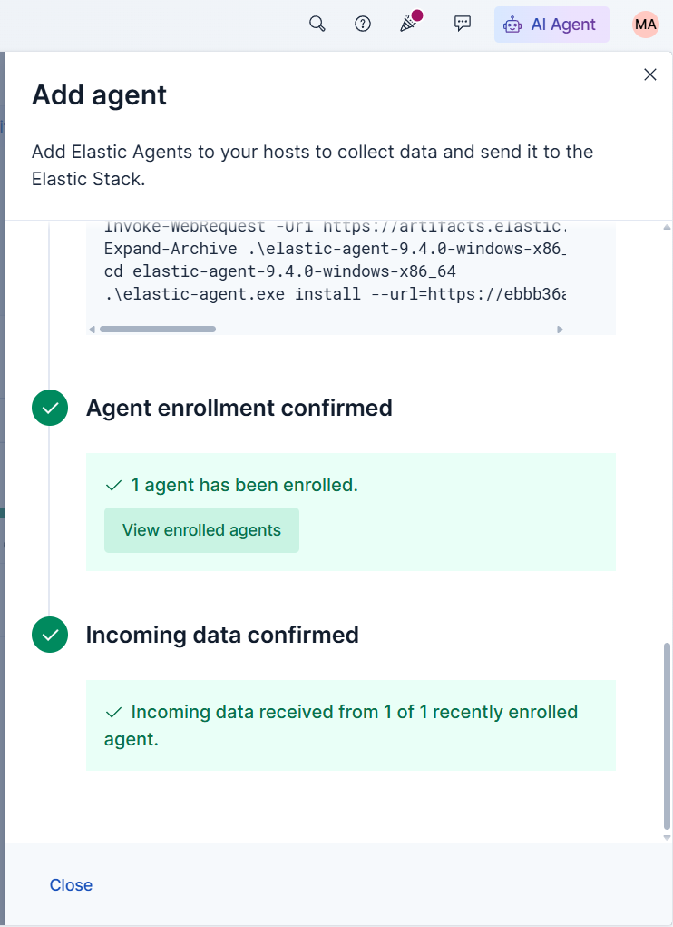
Once the installation was successful the agent enrolment was confirmed and incoming data was also confirmed to be used to actively listen to the log activity of the cloud endpoint.

Elastic Defend integration was carried out to provide data visibility and additional security
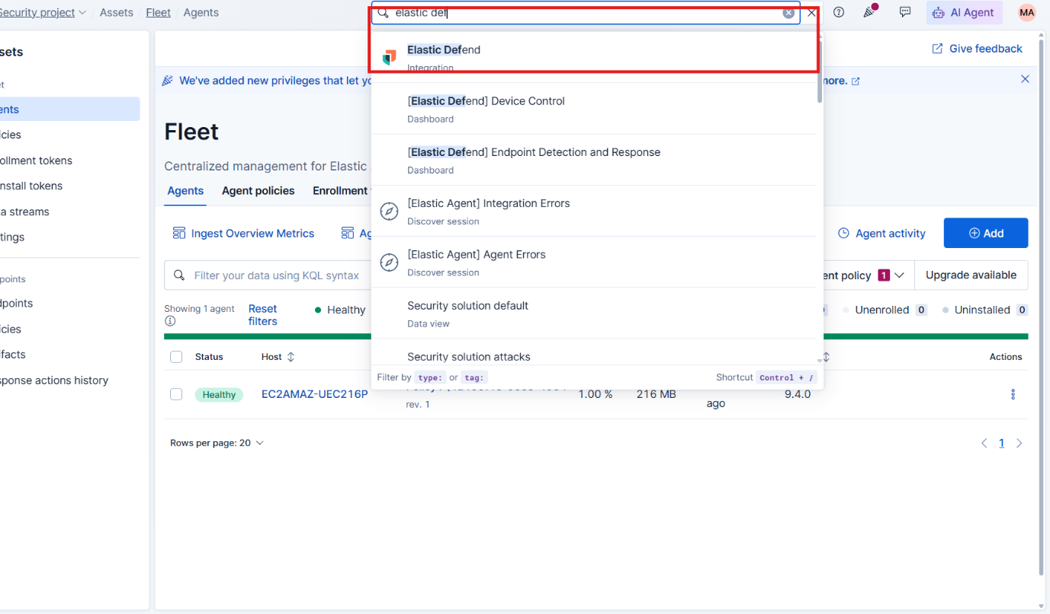

The following screenshots explain that elastic defend integration was added from the elastic SIEM dashboard by searching integration option.
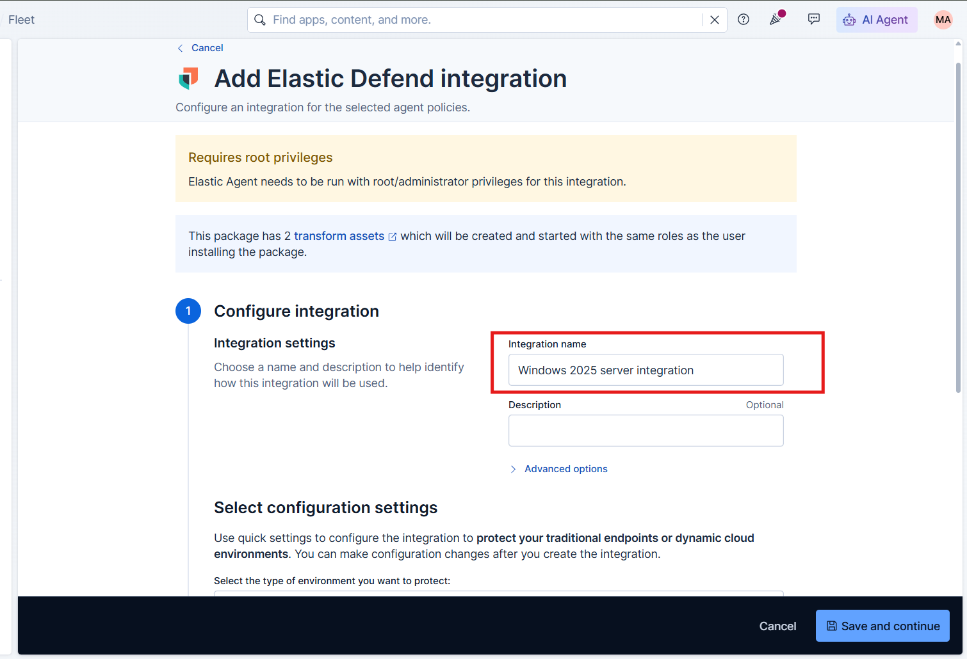
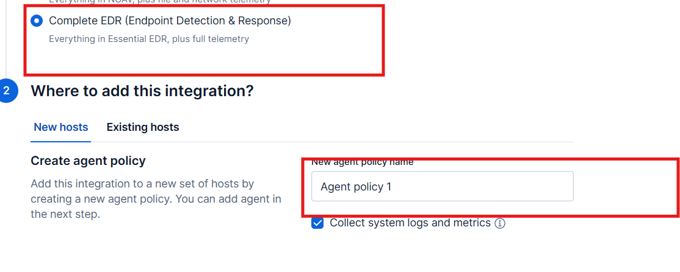


The following screenshots shows the elastic defend integration carried out by configuring the integration in following steps:
- Elastic integration name “Windows 2025 server integration”
- Complete EDR as the data collection
- Added into policy name :the policy name on which cloud endpoint was deployed

Later Ai integration part was intiated

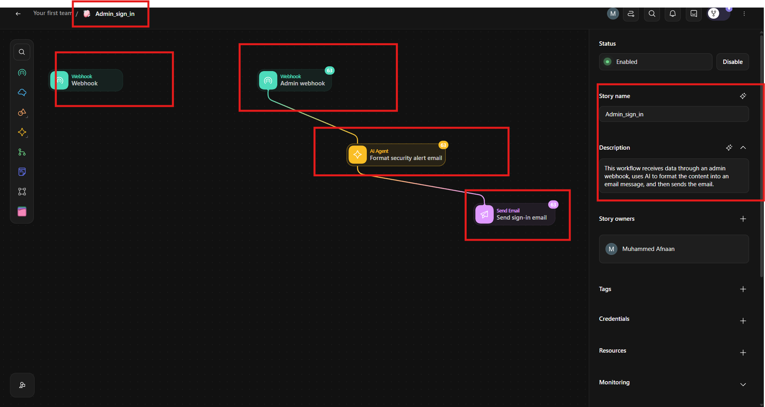
This screenshot explains Tines AI dashboard that has a webhook tool for receiving security alerts , AI agent for analysing security alerts, Send Email action for delivering the resulting security information to the analyst
This screenshot explains interconnection of Webhook, AI Agent, and Send Email actions to establish automated security workflow
alert received → AI analysis → analyst notification.
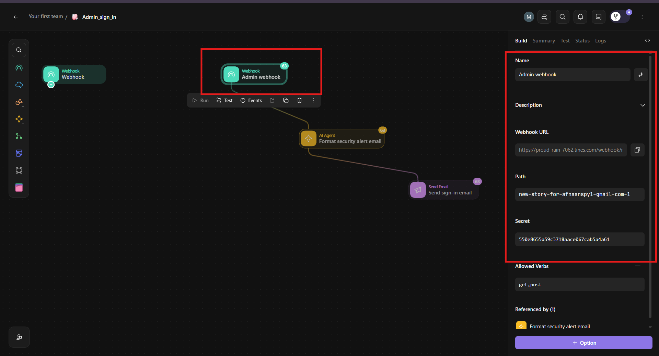
In this screenshot The tines Webhook URL was configured by adding a name, Webhook URL was was copied to be added into elastic integration through webhook connector in Elastic
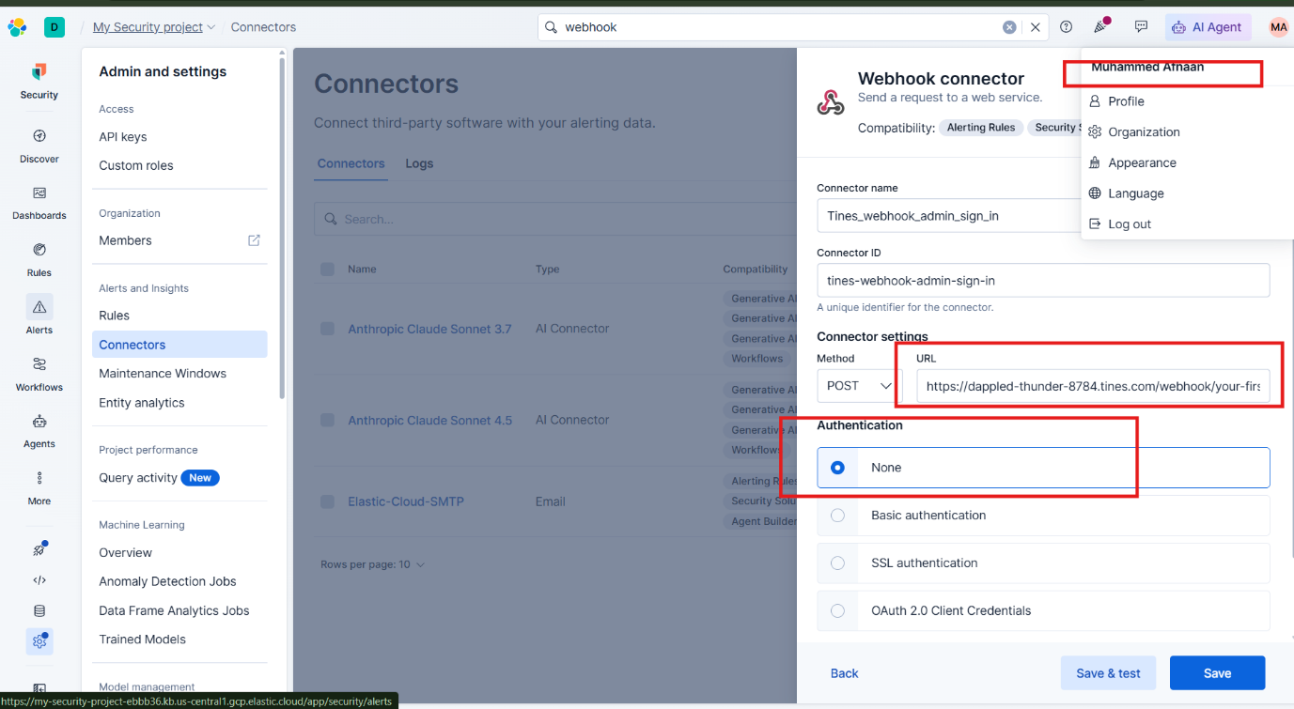
In this step the copied Webhook URL from Tines AI was pasted in webhook connectors through following navigation in Elastic Dashboard
Settings → Connectors → Webhook connector
Connector name was also given
The webhook URL was pasted under connector settings as POST request to establish communication between the elastic SIEM detection workflow and the Tines automation.

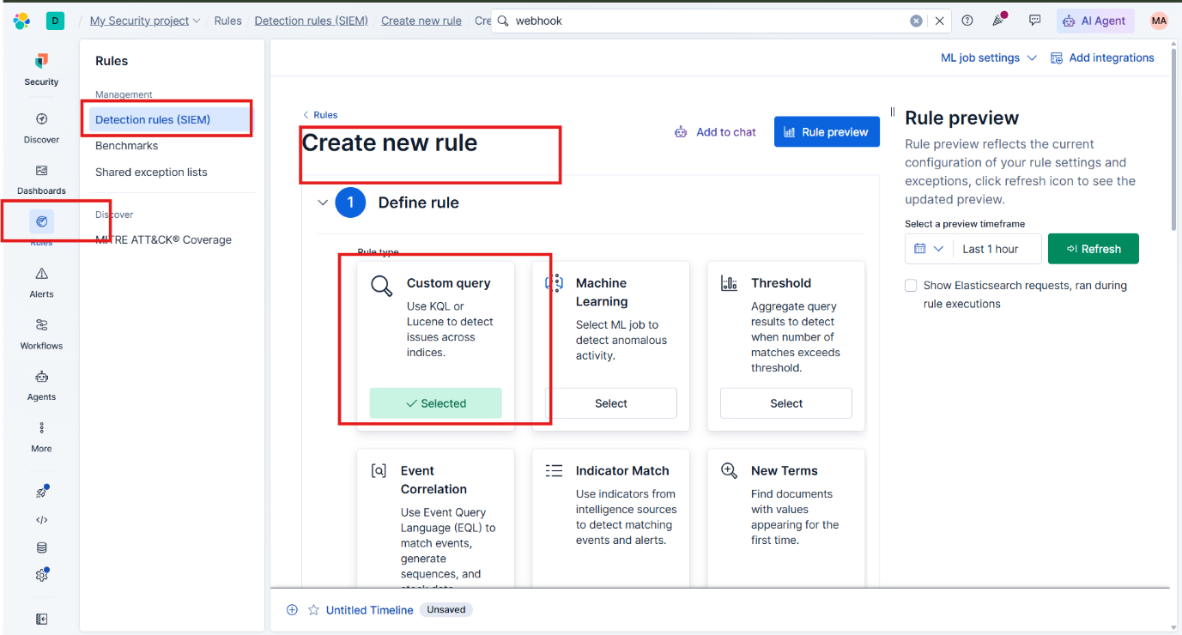

In this step Custom query detection rules were added to define administrative conditions under the created detection rule which will be triggered

Custom Query rule was selected by following steps
Rules→Detection rules(SIEM)→ Create new rule→Custom Query
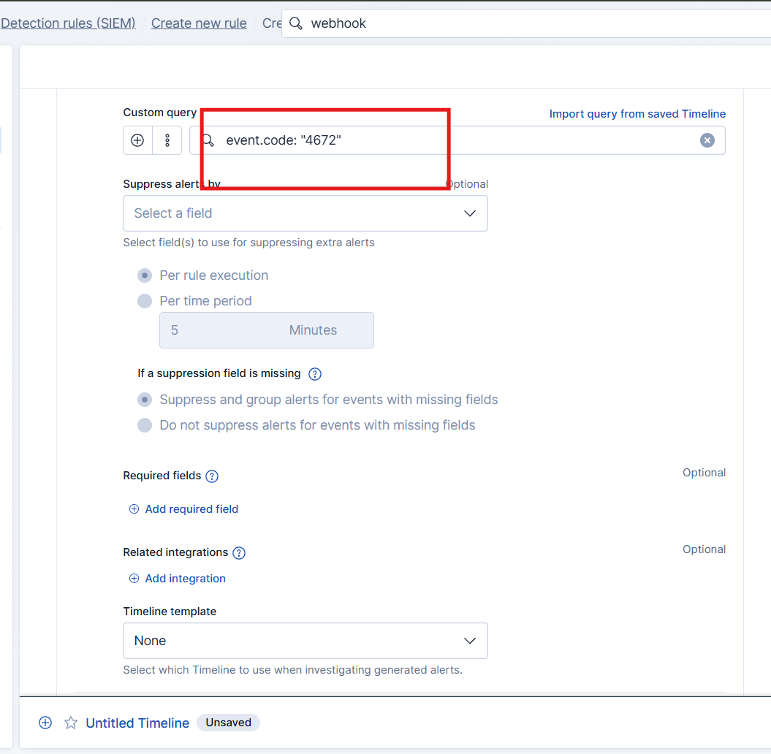
This screenshot explains custom query configuration done for identifying specific query related to administrative logon activity which is “event.code:”4672”
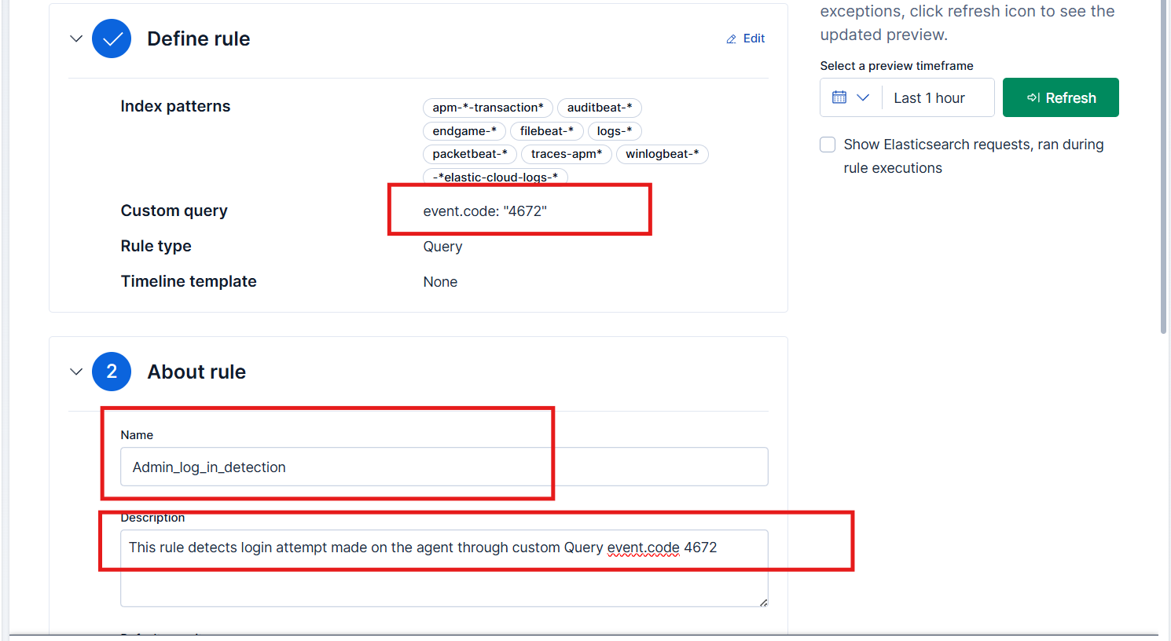
In this screenshot the rule name and description was added to the following custom query rule:event.code:” 4672”
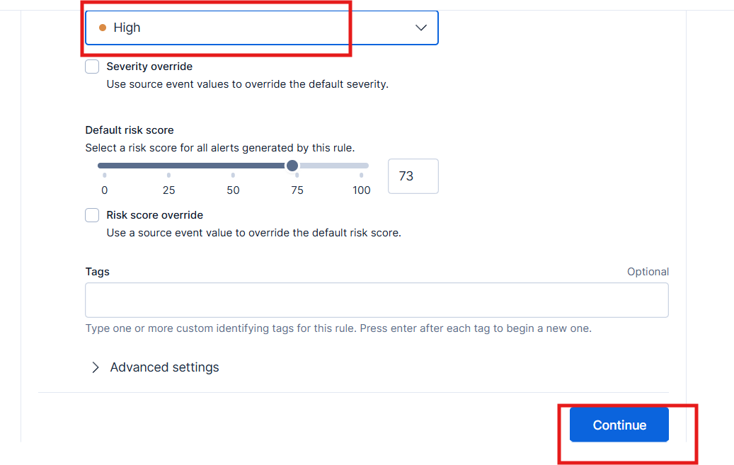
The severity of the rule was set to 73 explaining the seriousness of administrative logon in the endpoint
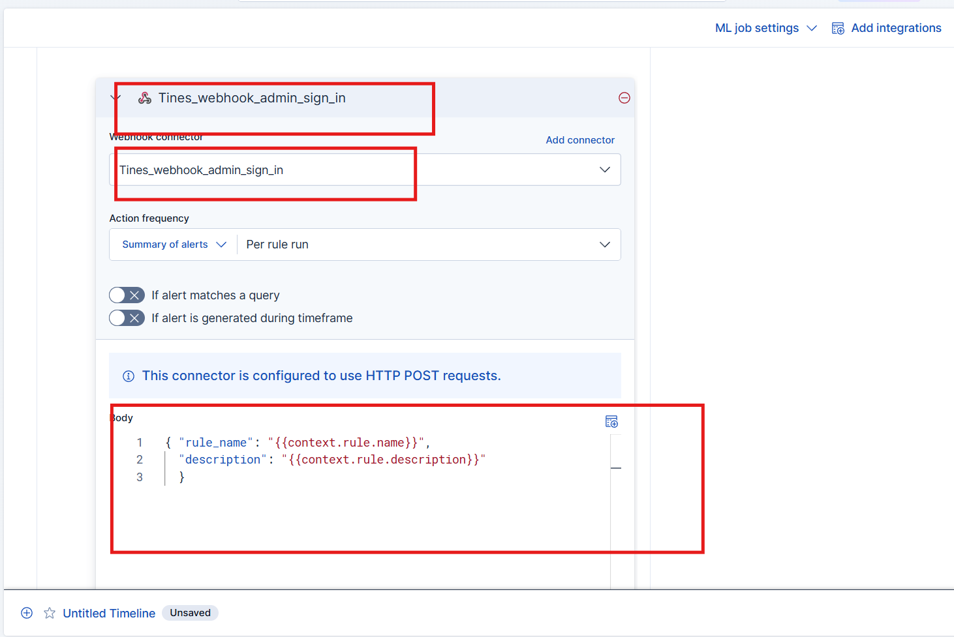
In the next step This rule was added to the existing Tines webhook connector within the Custom Query 4672 rule to automatically forward the rule information to Tines Workflow

Rule Description:
{
"rule_name" : "{{context.rule.name}}",
"description" : "{{context.rule.description}}"
}

The event code in XML:
<Event xmlns="http://schemas.microsoft.com/win/2004/08/events/event">
<System>
<Provider Name="Microsoft-Windows-Security-Auditing" Guid="{54849625-5478-4994-A5BA-3E3B0328C30D}" />
<EventID>4672</EventID>
<Version>0</Version>
<Level>0</Level>
<Task>12548</Task>
<Opcode>0</Opcode>
<Keywords>0x8020000000000000</Keywords>
<TimeCreated SystemTime="2015-09-11T01:10:57.091809600Z" />
<EventRecordID>237692</EventRecordID>
<Correlation />
<Execution ProcessID="504" ThreadID="524" />
<Channel>Security</Channel>
<Computer>DC01.contoso.local</Computer>
<Security />
</System>
<EventData>
<Data Name="SubjectUserSid">S-1-5-21-3457937927-2839227994-823803824-1104</Data>
<Data Name="SubjectUserName">dadmin</Data>
<Data Name="SubjectDomainName">CONTOSO</Data>
<Data Name="SubjectLogonId">0x671101</Data>
<Data Name="PrivilegeList">SeTcbPrivilege SeSecurityPrivilege SeTakeOwnershipPrivilege SeLoadDriverPrivilege SeBackupPrivilege SeRestorePrivilege SeDebugPrivilege SeSystemEnvironmentPrivilege SeEnableDelegationPrivilege SeImpersonatePrivilege</Data>
</EventData>
</Event>

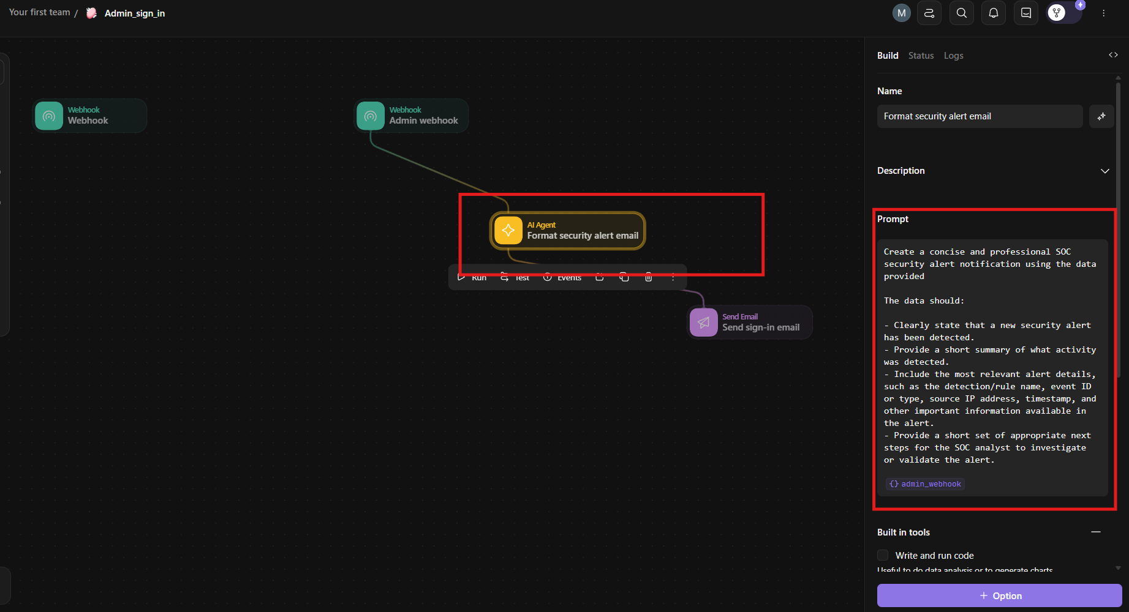

Coming back to the Tines workflow, AI agent action was configured by prompt instructions instructing the AI agent to summarise the detected event from the rule description and provide next actions steps for the analyst by adding the webhook action data tag from webhook
The prompt showed:
Create a concise and professional SOC security alert notification using the data provided The data should: - Clearly state that a new security alert has been detected. - Provide a short summary of what activity was detected. - Include the most relevant alert details, such as the detection/rule name, event ID or type, source IP address, timestamp, and other important information available in the alert. - Provide a short set of appropriate next steps for the SOC analyst to investigate or validate the alert.
<admin_webhook>
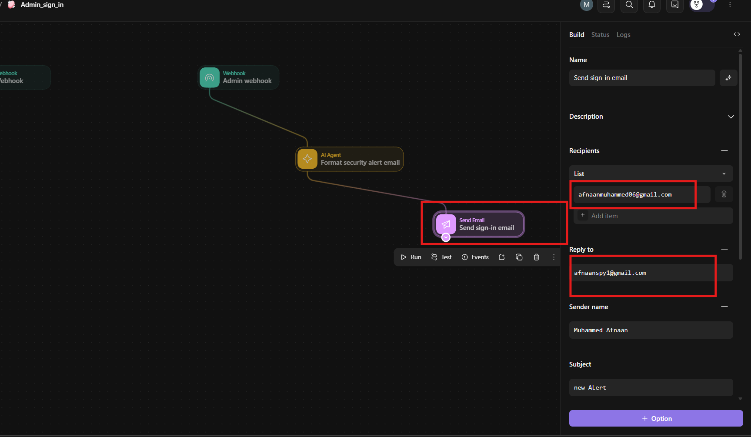

​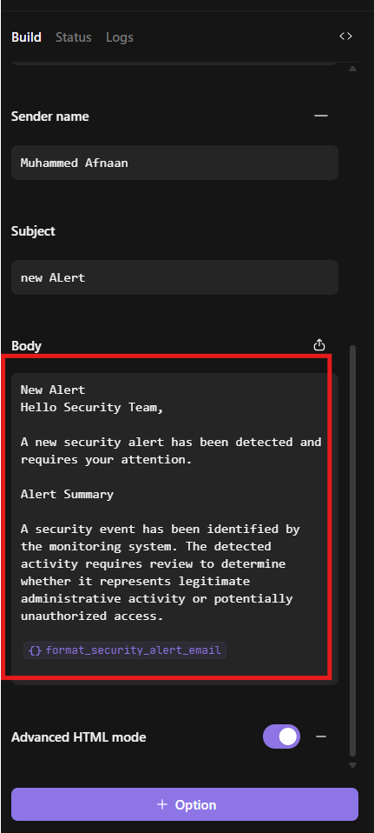
In the following screenshots Send Email acrion was configured by adding recipient email address ,Sender/Reply email address and email subject to deliver the email.
The email body was then configured to add a prompt saying: “New Alert Hello Security Team, A new security alert has been detected and requires your attention. Alert Summary A security event has been identified by the monitoring system. The detected activity requires review to determine whether it represents legitimate administrative activity or potentially unauthorized access. “ and adding the AI agent Data tag in the end of the text to allow summarised alert information along with recommended investigation steps inserted into the email before it is delivered

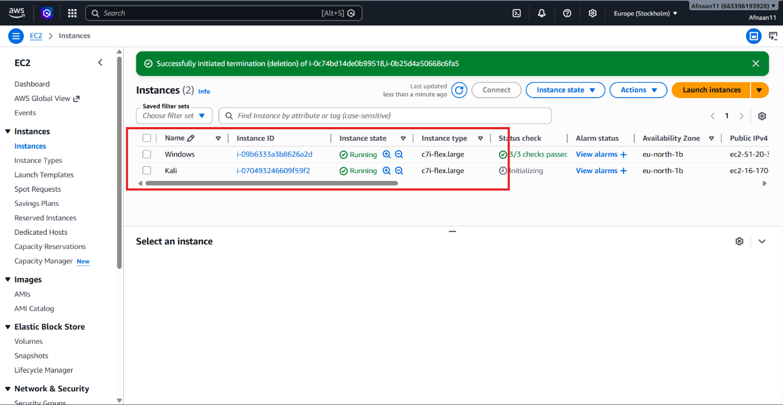
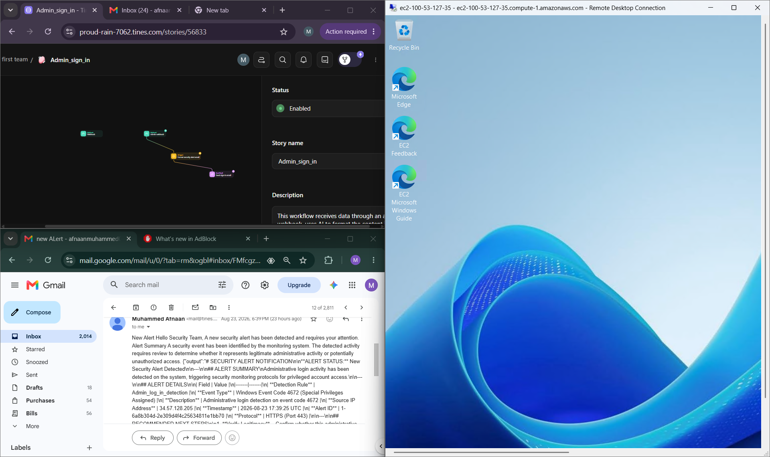

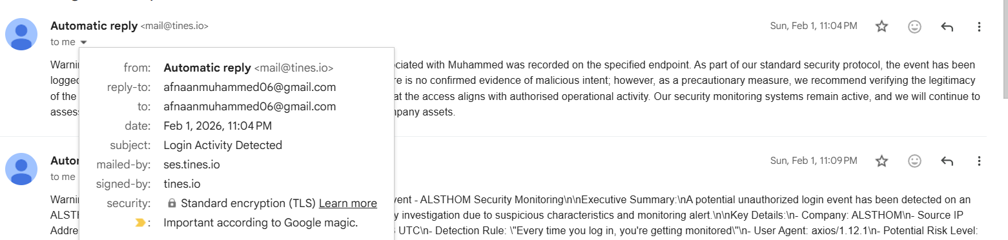
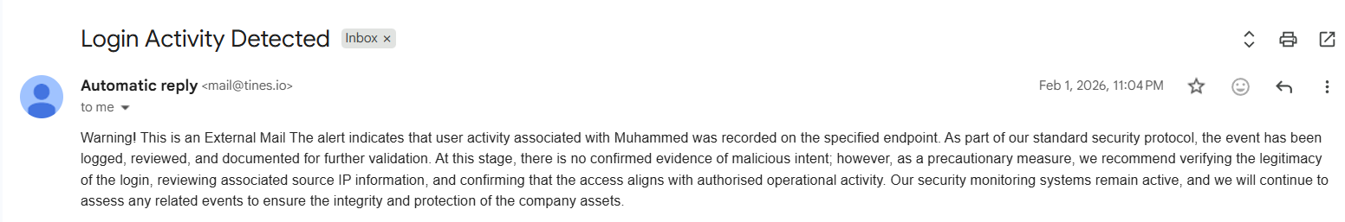

In the following screenshots it can be seen that when RDP login was attempted for windows cloud endpoint Windows event ID 4672 was triggered and automated through Tines AI workflow which analysed the activity and generated a structured security alert email.

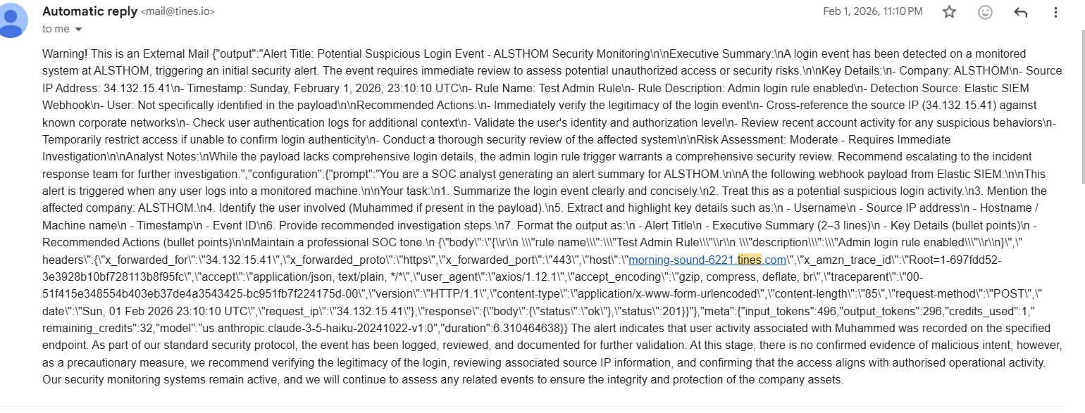

8.2 Practical demonstration II

Overview of the model:

using the proposed architecture discussed in practical demonstration 1
The zero trust protection layer for endpoints presented in this section demonstrates the implementation of Threatlocker tools within the proposed model. Due to commercial licensing requirements of the ThreatLocker platform, it was not possible to fully function in the trial environment, as it was not available for independent deployment during this research.
However, the implementation of a zero-trust layer is demonstrated through screenshots and learning materials obtained from Threatlocker's university online resource. These resources were used to study the platforms' configuration process, policy management, and zero trust controls that will develop an understanding of how Threatlocker would operate if it were deployed in the AWS Windows Server 2025 cloud endpoint.

Threatlocker’s application allowlisting
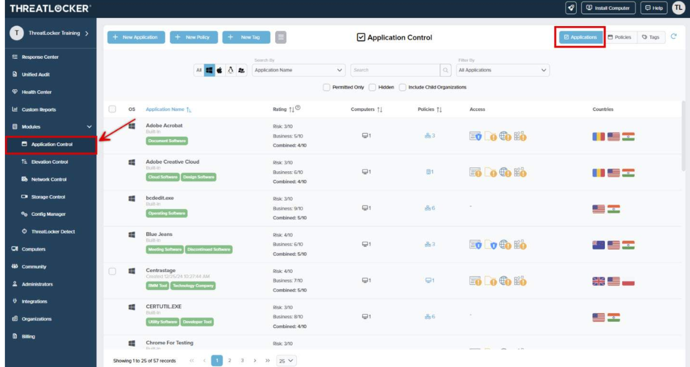
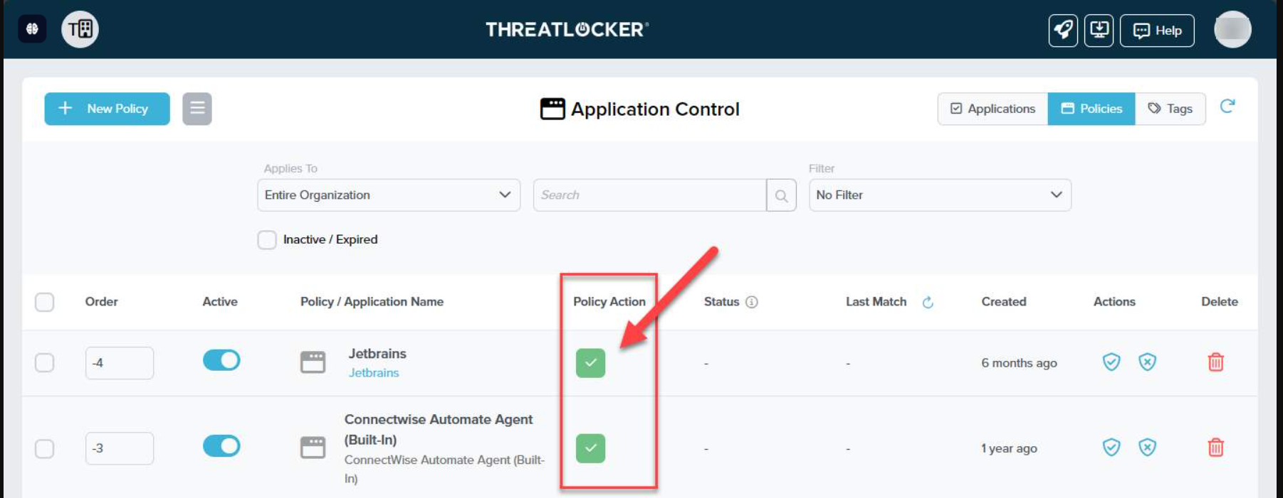
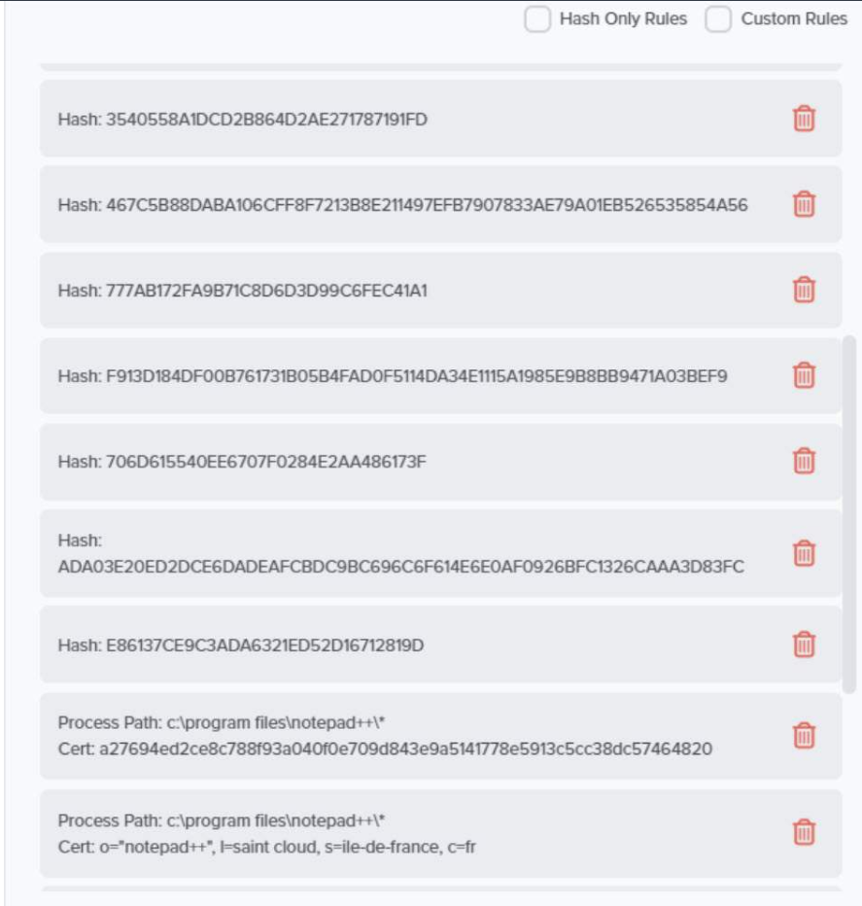
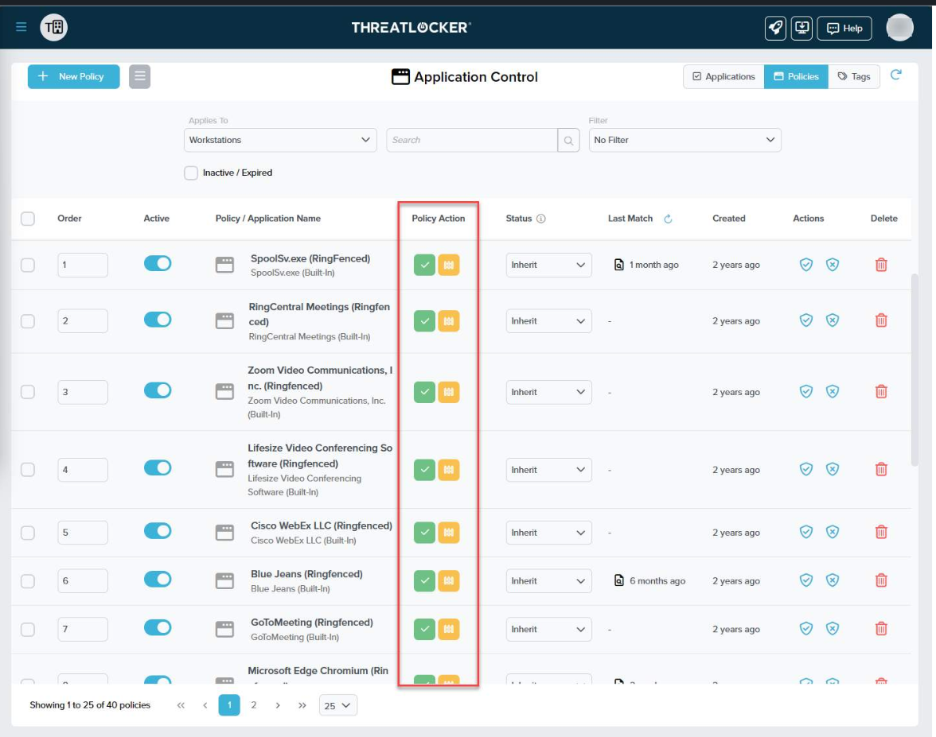
Ringfencing
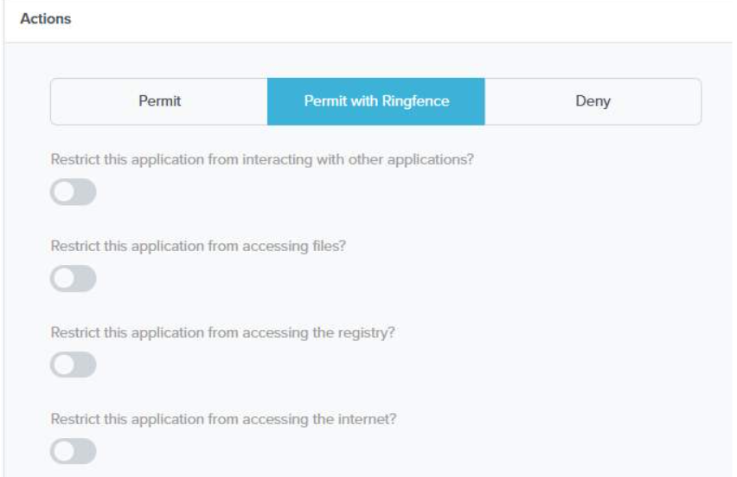
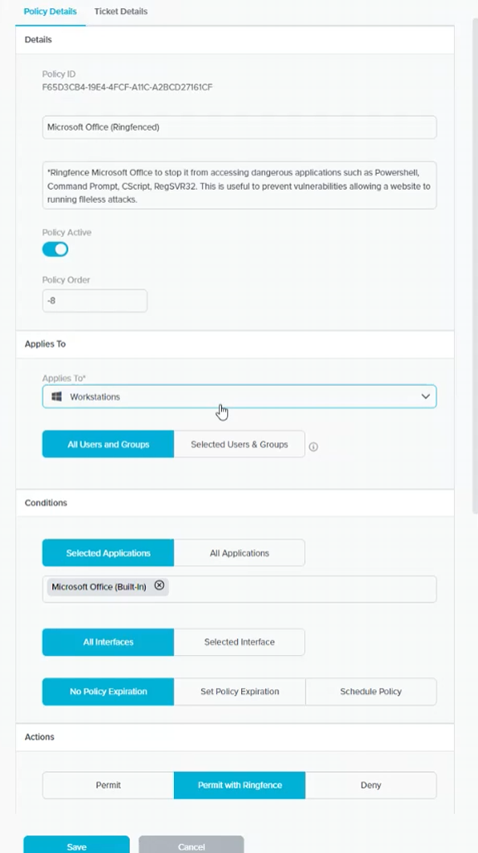
Storage control
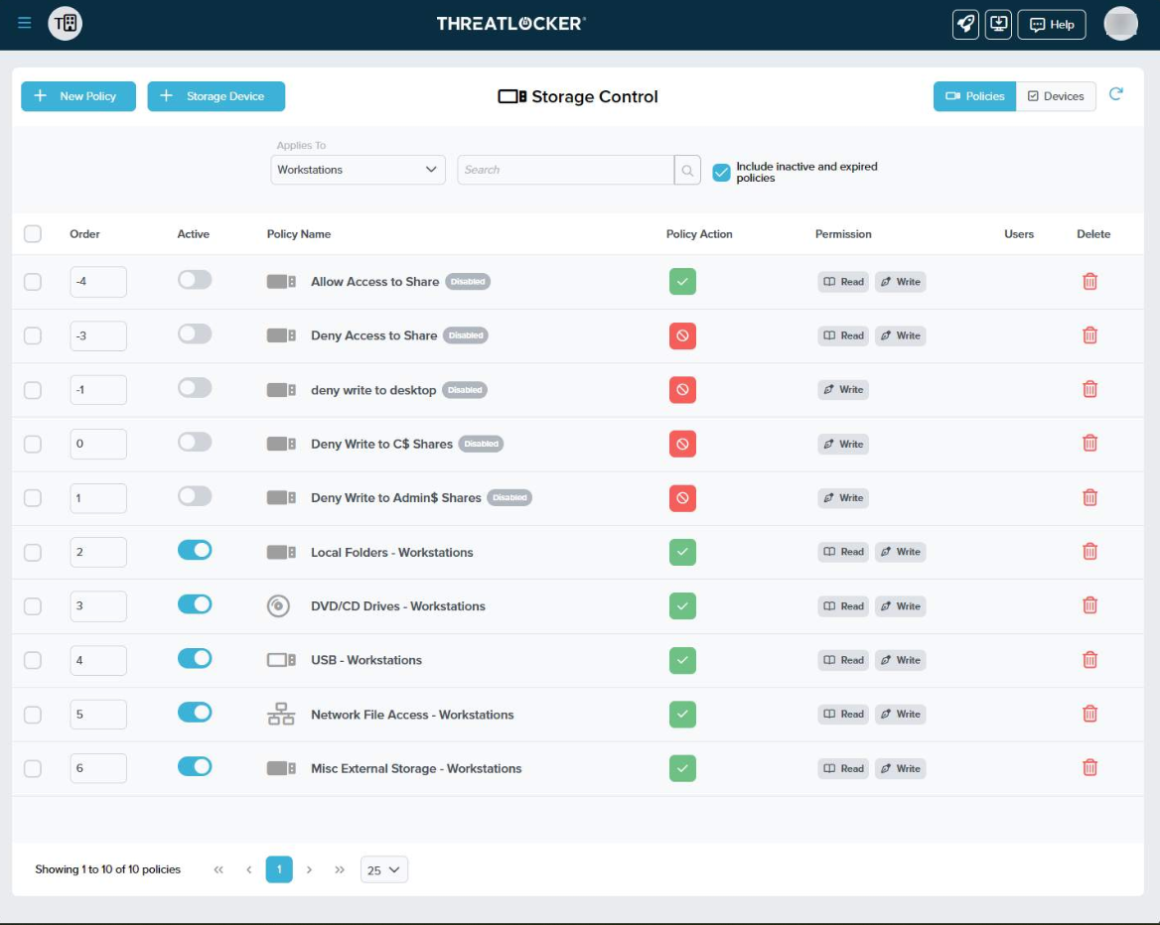

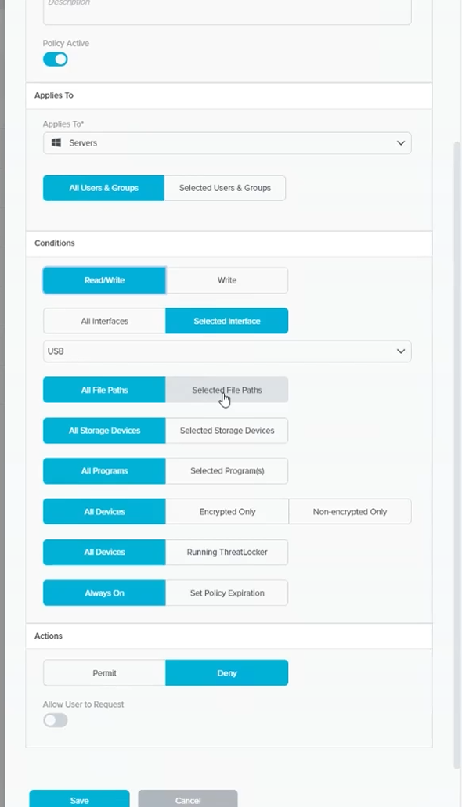
Default deny policy
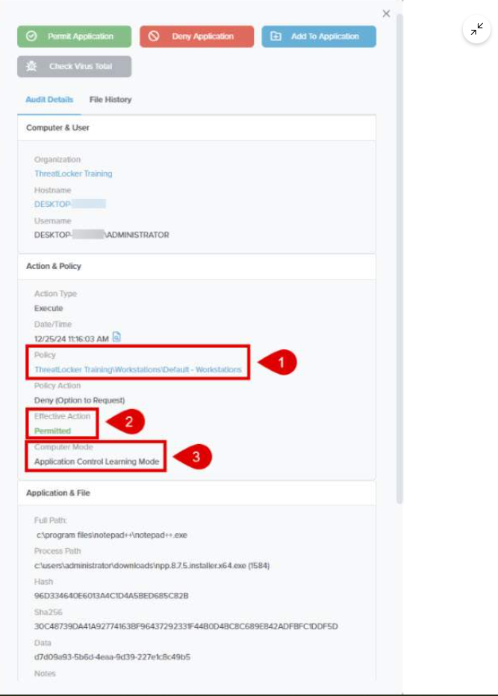
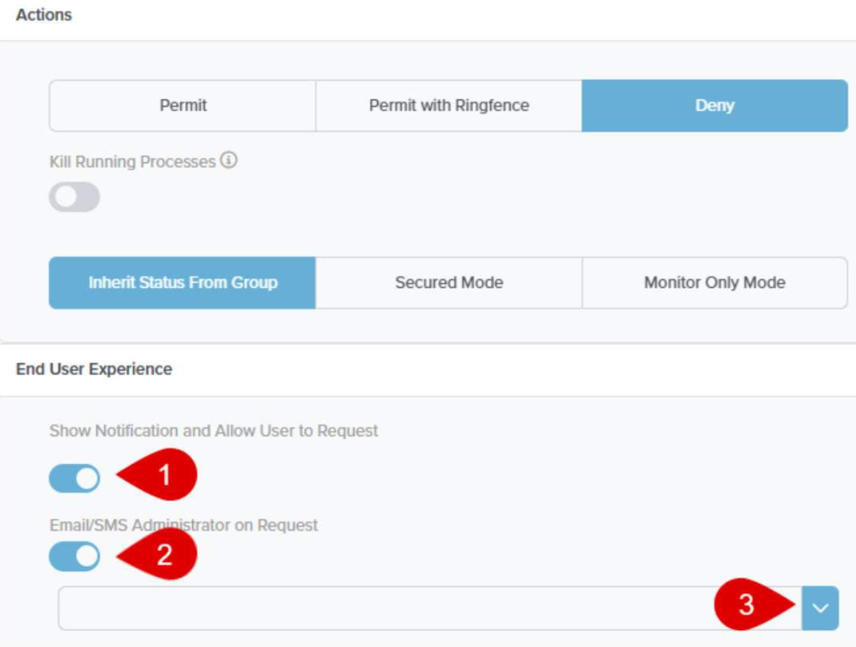

Chapter 9 Evaluation of the design

  - Overview
This section evaluates the proposed model through listing out the strengths and limitations.

Strengths of the proposed model

Extending Traditional SOC Worflows in cloud infrastructures
The proposed model enhances the conventional elastic SIEM workflow used in cloud infrastructure by integrating AI workflow automation, which replaces traditional SOC workflows that involve endpoint telemetry collection, elastic common schema normalisation, endpoint monitoring through Elastic Defend, detection rule capabilities, alert generation, and manual investigations. This new approach reduces the heavy reliance on security analysts to perform tasks manually, as it includes a workflow automation layer that conducts contextual analysis, generates structured alert summaries, identifies suspicious behaviour based on detection rules, and automates SOC workflow processes without disrupting the existing monitoring and detection mechanisms, thereby improving operational efficiency.

Implementation of the Principle of Least Privilege and Defence in Depth
The proposed model leverages artificial intelligence by integrating an automated orchestration pathway between Elastic SIEM and the Tines AI workflow automation tool. This integration facilitates the automatic transfer of security events generated in Elastic SIEM, specifically in relation to detection rule 4672. From this perspective, the model adheres to the principle of least privilege by monitoring and validating privileged activities identified on the Elastic SIEM platform in accordance with rule 4672. Additionally, it implements a defence-in-depth strategy using the ThreatLocker tool, which adds a layer of security through its set of controls. These controls are designed to detect, restrict, and prevent malicious activity across cloud endpoints.
The principle of least privilege is evident in the proposed model when the cloud endpoint is continuously monitored and validated for event ID 4672, which identifies detected administrative logon activity. Instead, since the administrator-level authentication has automatically trusted this proposed model, it treats privileged activity as a high-risk event that requires immediate validation and investigation.
When the event ID 4672 rule is fired, the alert generated is automated through the Elastic webhook connector to the Tines AI workflow automation tool, which processes the information, generates a contextual summary, identifies the nature of administrative activity and provides investigation summaries. Therefore, the proposed model boasts the principle of least privilege by reducing the implicit trust associated with administrative log-on activity, ensuring that only authorised access is continuously monitored and reviewed.
However, while Elastic SIEM and Tines AI signify the implementation aspect of the principle of least privilege, the threat locker provides enforcement mechanisms through its zero-trust endpoint controls, ensuring that users and applications operate only within predefined restricted boundaries. These zero trust endpoint controls include application allow-listing, default-deny policies, elevation control, ring fencing and storage control.
The default deny approach implemented by Threat Locker seeks to represent a significant improvement in cloud infrastructure by explicitly authorising approved applications running in the cloud endpoint and then encapsulating additional security restrictions applied through ring fencing to limit the behaviour and interaction of the applications within the endpoint. Furthermore, elevation control ensures that only authorised administrative privileges are granted for a limited time.
Therefore, the proposed model demonstrates defence in depth by creating a structured layer of protection throughout the attack lifecycle. For instance, if an attacker is successful in gaining privileged credentials to log into the cloud endpoint, generating an event ID 4672, Elastic SIEM and Tines provide detection and investigative capabilities. However, if the detection mechanism fails or produces a false positive, ThreatLocker's deny-by-default policy prevents unauthorised applications from running. Even if an authorised application is abused by an attacker, ring fencing restricts its behaviour. If an attacker attempts to filter data exfiltration through external storage, the storage control feature provides an additional restriction layer.
These multiple layers of protection demonstrate that the proposed model does not heavily rely on a single security mechanism; yet, it combines AI-assisted detection and zero-trust endpoint restriction mechanisms, representing a practical implementation of two principles of cybersecurity: the principle of least privilege and defence in depth.

Limitations

Chapter 10 Critical Evaluation

10.1 Findings Against Research

  - Overview

In this section, a critical evaluation of the proposed model will be conducted, comparing it with findings from existing research to assess the effectiveness of the proposed AI-driven security workflow automation. This evaluation will focus on operational metrics, including incident response time, incident detection time, false positive rate, and successful mitigation.
The findings from previous research done by Narayan, Yogendra, et al. . 18 Sept. 2025
on their architecture of an AI-based incident response model will be compared against the practical outcomes observed in the proposed model to identify similarities, improvements, and limitations. This analysis will be conducted using tabular and graphical representations to provide a clear comparison between the traditional rule-based AI approach, machine learning approaches, and the proposed AI-driven workflow automation architecture.

10.2 Metric Evaluation

Table 1: Incident Reponse Performance Comparison

Metrics | AI workflow model implementation based on literature review Narayan, Yogendra, et al. . 18 Sept. 2025 | Proposed Tines AI workflow | Improvement in Metrics
Average Incident Detection time in secs | 350 | 50 | 85.7% Reduction
Average Incident Response Time in mins | 45 | 2 | 95.6% Reduction
False Positives per month | 500 | 50 | 90% Reduction
Successful Mitigation in % | 75% | 99% | +24 % increase

Table one shows comparative results between AI workflow model implementations carried out by researchers and the proposed Tines AI workflow model, indicating that the proposed model should reduce the average incident detection time from 352 seconds to 50 seconds, representing an 85% improvement in reduction. Similarly, the average incident response time decreased from 45 minutes to 2 minutes. Similarly, the number of false positives and false negatives has also decreased, improving the overall successful mitigation from 75% to 99%, indicating that the proposed model could be a better approach for cloud-based supply chains.
The justified reason for this metric is that each time the cloud endpoint generates alerts, the AI workflow automation immediately analyzes and investigates the alerts, improving alert orchestration and assisting analysts in making quick decisions in responding to alerts from cloud environments, thus improving the incident response lifecycle through AI.

Table 2: Comparison based on Cyber Threat Detection and AI approaches

Approach Based | Detection Accuracy in % | False Positive % | False Negative in %
Traditional Rule-Based Approach | 78% | 22% | 30%
Machine Learning Model | 90% | 11% | 14%
Deep learning Model | 97% | 6% | 8%
Proposed Model | 97% | 8% | 7%

10.3 Evaluation Against Threat landscape
This section explains the critical evaluation of the proposed model against the current threat landscape, aligning to MITRE ATT&CK tactics, techniques, and procedures, considering the most common and emerging attack scenarios that affect cloud environments, focusing specifically on compromised credentials, privileged account abuse, and lateral movement of attack. Street scenarios are mapped against the capabilities of the proposed model to determine how effective it is in terms of detecting and preventing the associated activity. Through this comparison, a real-world overview of cloud security could be demonstrated.

Testing Case: Privileged Administrative Logon Activity

TTP: Privileged Account Login
Windows Event: Event ID 4672
Target Machine: AWS EC2 instance (Cloud Endpoint)
Detection Platform: Elastic SIEM
Automation: Tines AI


In this case, detection of privileged logon activity on Windows Server 2025 is being evaluated through the diagram. This diagram explains that a remote login performed in the cloud endpoint through RDP results in the generation of Windows security event ID 4672, indicating that special privileges were assigned to a new login session; however, the event was collected by Elastic Defend and forwarded to Elastic SIEM to ingest a detection rule for event ID 4672. When the rule is triggered, the resulting alert is automatically transmitted to Tines AI through the webhook integration, where the Tines AI agent analyses the received alert and provides a structured incident summary with recommended investigation actions in an email format, which is forwarded to analysts to make decisions.

This scenario maps to MITTRE ATT&CK T1558 Related Detection

MITTRE ATT&CK T1558 overview
TTP: Stealing Kerberos Tickets T1558
Target Machine: Windows Server 2025
Event ID: Windows Event ID 4672,4634
Proposed Detection Platform: Elastic SIEM
AI Analysis: Tines AI
https://attack.mitre.org/detectionstrategies/DET0522/

THE T1558 STEAL OR FORGE KERBEROS TICKETS TTP represents a credential access tactic used by an attacker to obtain Kerberos authentication tickets to gain authorized access to systems; this may potentially allow them to compromise systems and gain elevated access without directly compromising the user's password within the MITRE ATT&CK detection strategies. Session events for Windows logon, such as event ID 467 to event ID 4634, can provide relevant telemetry for identifying activity associated with privileged authentication. Event ID 4672 is used as the primary indicator in the proposed model to identify privileged logon activity on the cloud endpoint. Although this event does not independently confirm Kerberos ticket theft or forgery, it provides relevant visibility into privileged authentication activity that can be investigated in the context of credential access threats.

11) References
Adriano Serckumecka, et al. CCE: A Cloud-Based SIEM Correlation Engine Built on Serverless Functions. 29 Sept. 2025, pp. 95–105, ieeexplore.ieee.org/stamp/stamp.jsp?tp=&arnumber=11360458, https://doi.org/10.1109/srds69199.2025.00022. Accessed 4 Mar. 2026.
Anupa, J., and K. Chandra Sekaran. “Cloud Workflow and Security: A Survey.” 2014 International Conference on Advances in Computing, Communications and Informatics (ICACCI), Sept. 2014, pp. 1598–1607, ieeexplore.ieee.org/document/6968496, https://doi.org/10.1109/icacci.2014.6968496. Accessed 7 Jan. 2026.
Breachsense. “Capital One Data Breach: How 106 Million Records Were Stolen.” Breachsense.com, 2026, www.breachsense.com/blog/capital-one-data-breach-case-study/.
Carlson, Teressa. The State of Cloud-Driven Transformation.
Chyun Horng Chi, et al. Intelligent-Based SIEM Security Email Alert. 23 Aug. 2023, https://doi.org/10.1109/icoict58202.2023.10262562.
Cinque, Marcello . “Challenges and Directions in Security Information and Event Management (SIEM) - IEEE Conference Publication.” Ieee.org, 2018, ieeexplore.ieee.org/stamp/stamp.jsp?tp=&arnumber=8539170.
FARZAAN. “IEEE Xplore Full-Text PDF”: Ieee.org, 2026, ieeexplore.ieee.org/stamp/stamp.jsp?tp=&arnumber=10979487. Accessed 25 Feb. 2026.
Guha, Debanksh, et al. A Practical Implementation of Zero Trust Architecture for Securing Web-Based Applications. 16 May 2025, pp. 1–6, https://doi.org/10.1109/assic64892.2025.11158196. Accessed 13 Oct. 2025.
Kim, Dasol, et al. “A Comparative Security Analysis of Storage-Integrated Web Applications in Heterogeneous Cloud Environments.” 2025 12th International Conference on Social Networks Analysis, Management and Security (SNAMS), 25 Nov. 2025, pp. 30–37, ieeexplore.ieee.org/stamp/stamp.jsp?tp=&arnumber=11391049, https://doi.org/10.1109/snams67467.2025.11391049. Accessed 4 Mar. 2026.
Kotenko, Igor, et al. “Aggregation of Elastic Stack Instruments for Collecting, Storing and Processing of Security Information and Events.” IEEE Xplore, 1 Aug. 2017, ieeexplore.ieee.org/abstract/document/8397627. Accessed 21 Aug. 2021.
Nagababu Garigipati, et al. A Multi-Layered Hybrid Security Algorithm Based on Integrity for the Cloud Computing Environment. 19 July 2023, https://doi.org/10.1109/icecaa58104.2023.10212405. Accessed 29 Jan. 2024.
Narasappa, Dharnisha. “Integrating Zero Trust Architecture with Automation and Analytics for Resilient Cybersecurity.” 2025 3rd International Conference on Data Science and Network Security (ICDSNS), 25 July 2025, pp. 1–6, https://doi.org/10.1109/icdsns65743.2025.11168551. Accessed 12 Jan. 2026.
Narayan, Yogendra, et al. Strengthening Network Security through the Implementation of AI-Driven Automated Incident Response Systems. 18 Sept. 2025, pp. 1–5, ieeexplore.ieee.org/document/11233253, https://doi.org/10.1109/icccnp63914.2025.11233253. Accessed 7 Jan. 2026.
Roy, Hannah. “Understanding Your Tines Deployment Options.” Tines.com, Tines, 15 Jan. 2026, www.tines.com/blog/understanding-your-tines-deployment-options/. Accessed 4 Mar. 2026.
SIMIN LI . “Design and Computational Modeling of an AI-Based Automated Cybersecurity Incident Response System.” Ieee.org, 2026, ieeexplore.ieee.org/stamp/stamp.jsp?tp=&arnumber=11145017. Accessed 2 Mar. 2026.
Sorn, Jacob, et al. Exploring the CAM4 Data Breach: Security Vulnerabilities and Response Strategies. 4 May 2024.
Sornalakshmi, K. “Detection of DoS Attack and Zero Day Threat with SIEM.” 2017 International Conference on Intelligent Computing and Control Systems (ICICCS), June 2017, https://doi.org/10.1109/iccons.2017.8250515. Accessed 19 May 2020.
Threatlocker. “Zero Trust Endpoint Security | ThreatLocker, Inc.” Www.threatlocker.com, www.threatlocker.com/.
University, Threatlocker. “Loading.” Docebosaas.com, 2026, threatlocker.docebosaas.com/learn. Accessed 7 Jan. 2026.
Wei, Yu Chih, and Tak Wai Yu. “Zero Trust Framework in Financial Sector: The Handling of Machine Learning Based Trust Management.” IEEE Xplore, 1 July 2023, ieeexplore.ieee.org/document/10226959.

12 Appendices

